**Lab25– Understanding CDN Profiles and Endpoint – Azure**

**Content delivery network**

A content delivery network (CDN) is a distributed network of servers that can efficiently deliver web content to users. CDNs store cached content on edge servers in point-of-presence (POP) locations that are close to end users, to minimize latency.

Azure Content Delivery Network (CDN) offers developers a global solution for rapidly delivering high-bandwidth content to users by caching their content at strategically placed physical nodes across the world. Azure CDN can also accelerate dynamic content, which cannot be cached, by leveraging various network optimizations using CDN POPs. For example, route optimization to bypass Border Gateway Protocol (BGP).

The benefits of using Azure CDN to deliver web site assets include:

* Better performance and improved user experience for end users, especially when using applications in which multiple round-trips are required to load content.
* Large scaling to better handle instantaneous high loads, such as the start of a product launch event.
* Distribution of user requests and serving of content directly from edge servers so that less traffic is sent to the origin server.

|  |  |
| --- | --- |
| [Check Name Availability](https://docs.microsoft.com/en-us/rest/api/cdn/checknameavailability) | Verify the uniqueness of resource names. |
| [Check Resource Usage](https://docs.microsoft.com/en-us/rest/api/cdn/resourceusage) | Discover quotas and usage of CDN profiles. |
| [Custom Domains](https://docs.microsoft.com/en-us/rest/api/cdn/customdomains) | Provides operations for working with CDN custom domains. |
| [Edge Nodes](https://docs.microsoft.com/en-us/rest/api/cdn/edgenodes) | Obtain information about CDN edge nodes. |
| [Endpoints](https://docs.microsoft.com/en-us/rest/api/cdn/endpoints) | Create, validate, start, stop, and delete CDN endpoints. Pre-load and purge cached endpoint content. |
| [List Operations](https://docs.microsoft.com/en-us/rest/api/cdn/operations) | Provides information about CDN REST API operations. |
| [Origins](https://docs.microsoft.com/en-us/rest/api/cdn/origins) | Manage origins within an endpoint. |
| [Profiles](https://docs.microsoft.com/en-us/rest/api/cdn/profiles) | Operations for managing CDN profiles. A CDN profile is a collection of CDN endpoints. |

**Topology:**

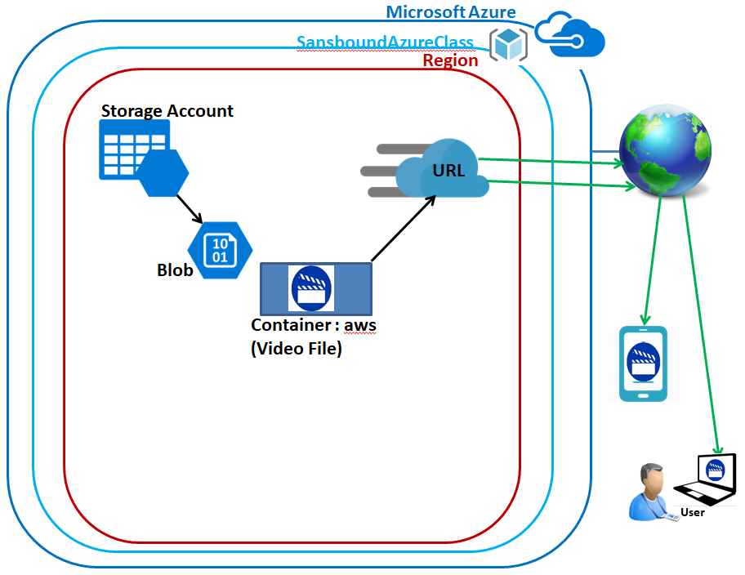

**Backend Topology:**

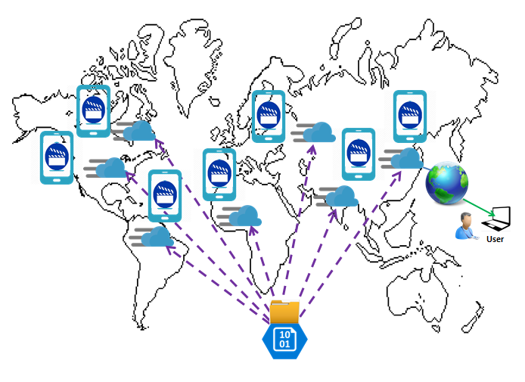

In Azure portal, click **“Resource groups”**.

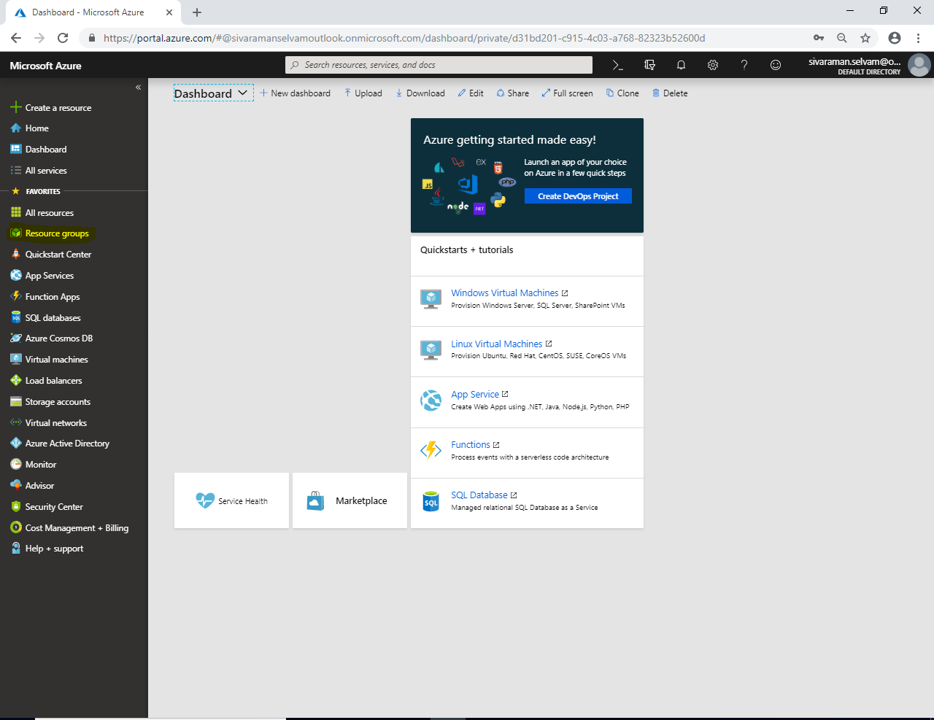

In **“Resource groups”** click **“Add”**.

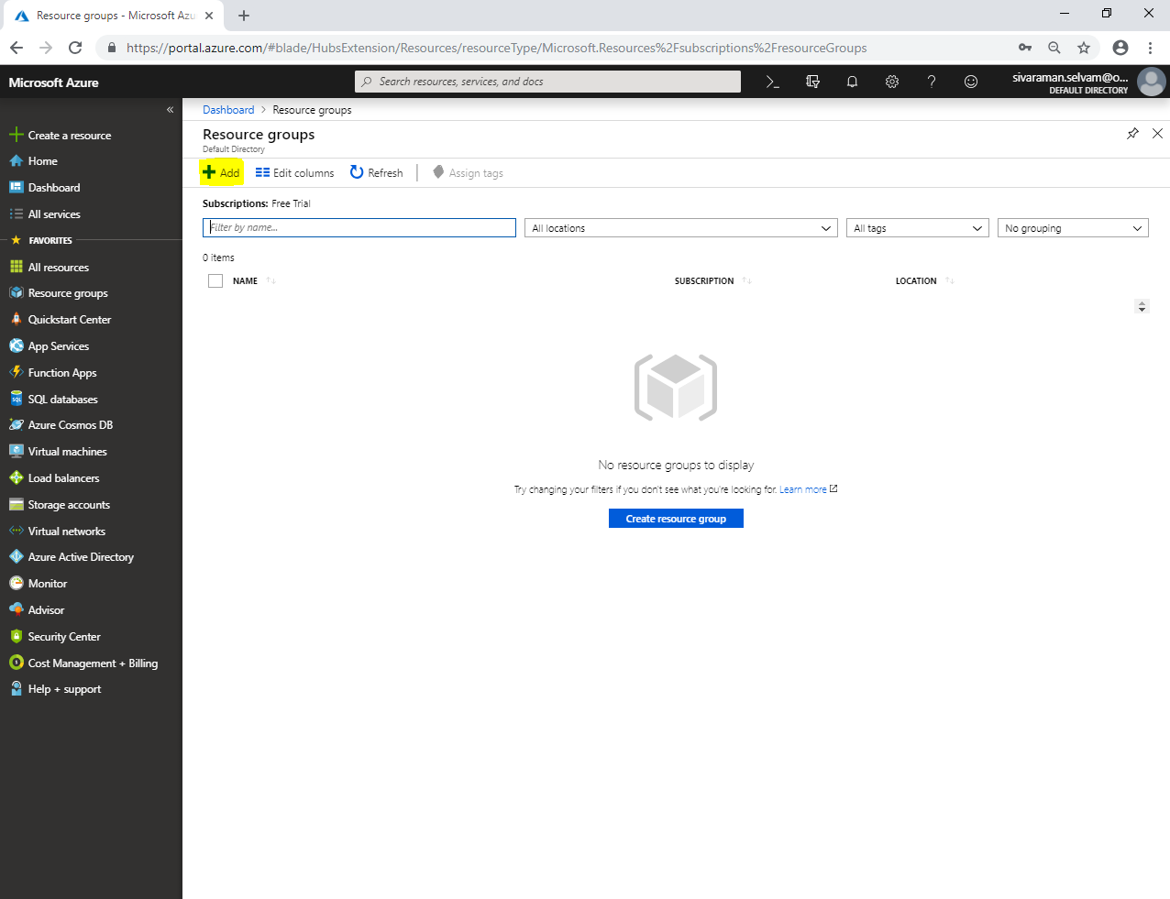

While create a resource group,

Select **“Subscription”** as **“Free Trial”.**

Type **“Resource group”** name as **“SansboundAzureClass”**.

Select **“Region”** as **“Central US”**.

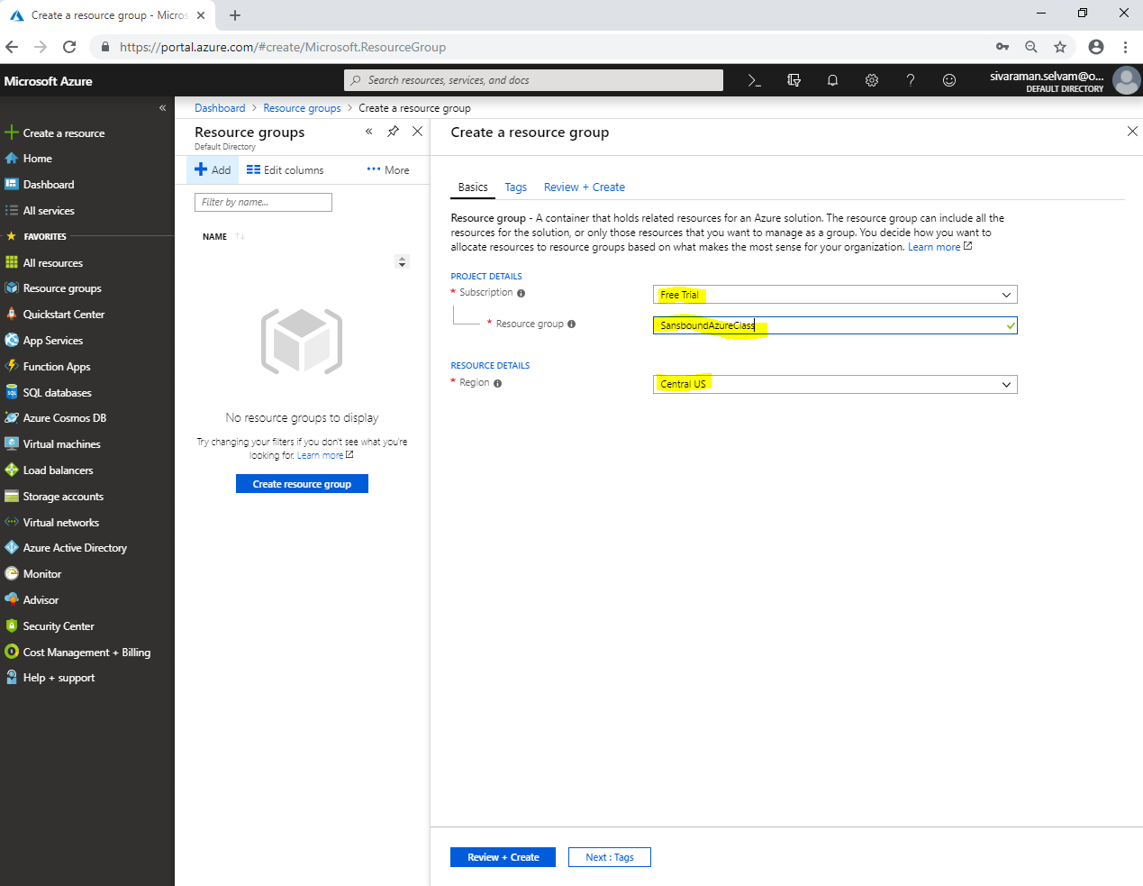

Click **“Review + create”**.

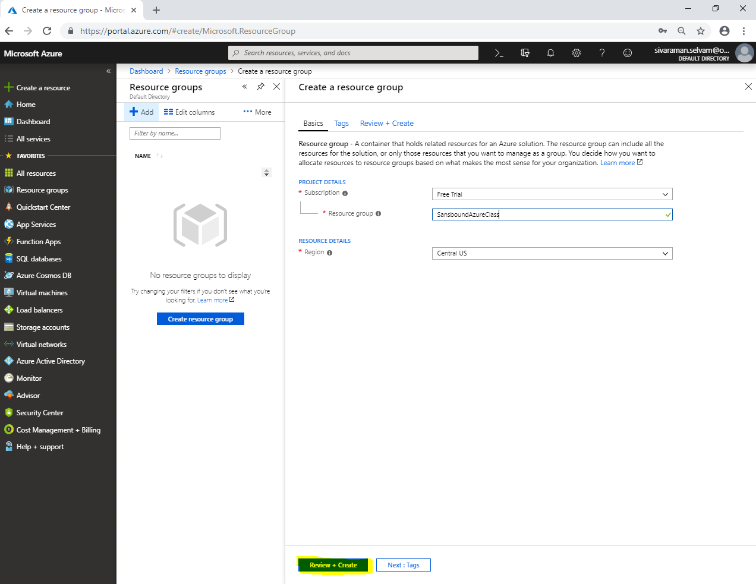

Click **“Create”**.

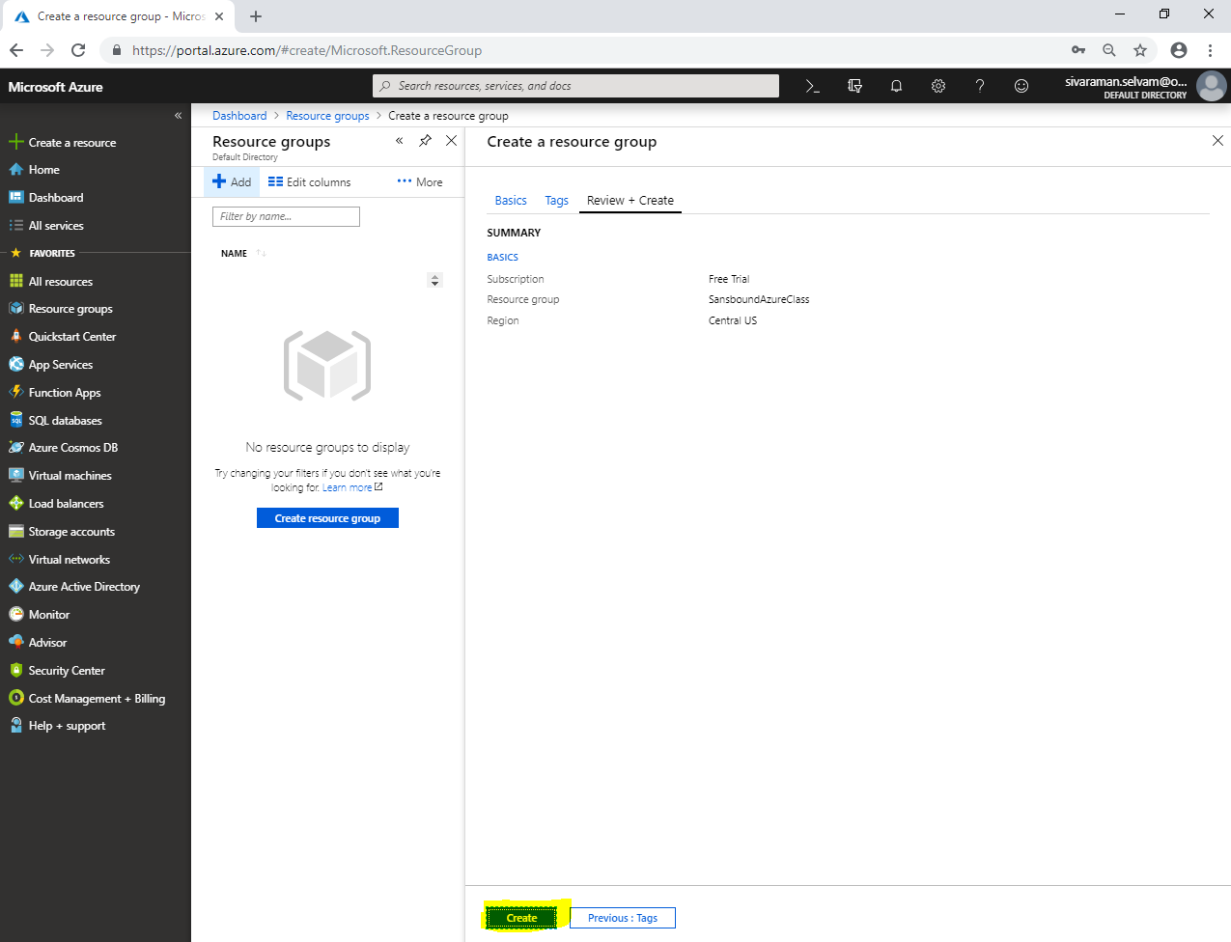

Click **“Storage accounts”**.

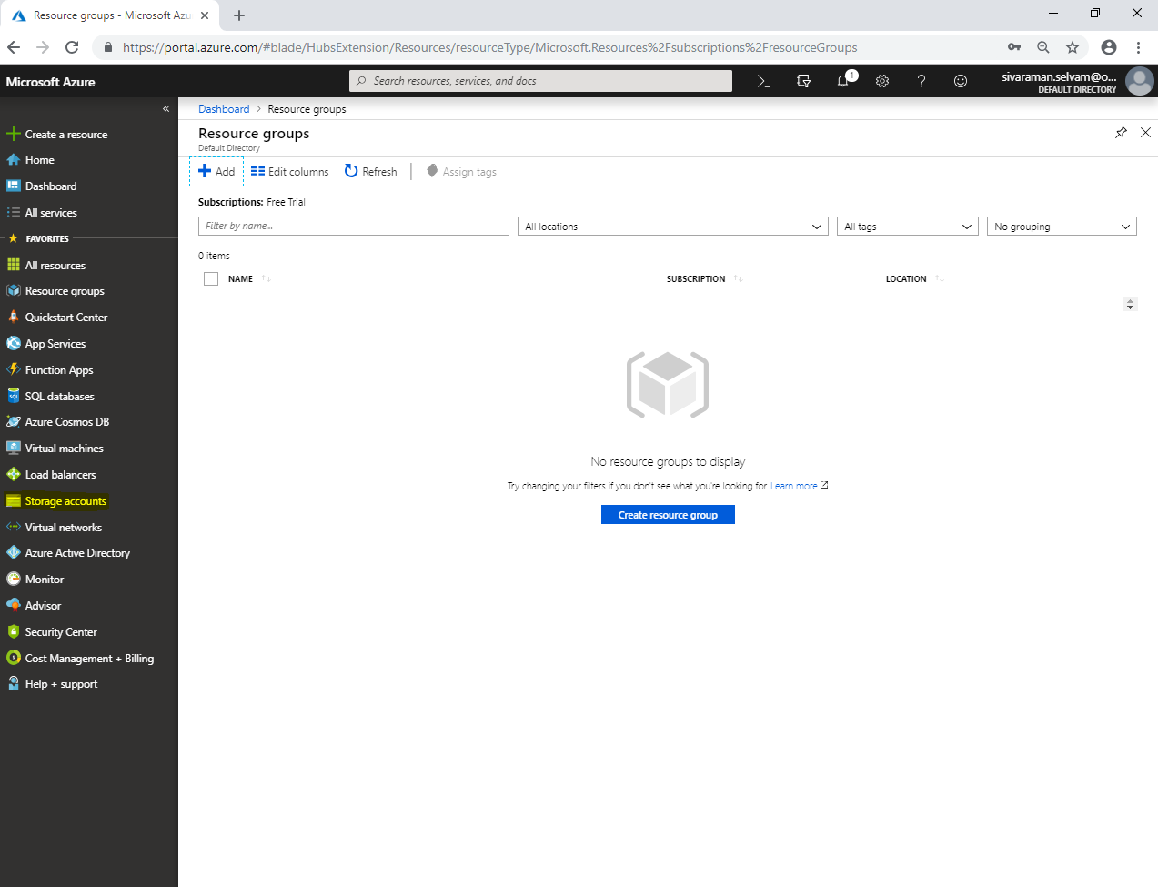

In **“Storage accounts”**,

Click **“Add”**.

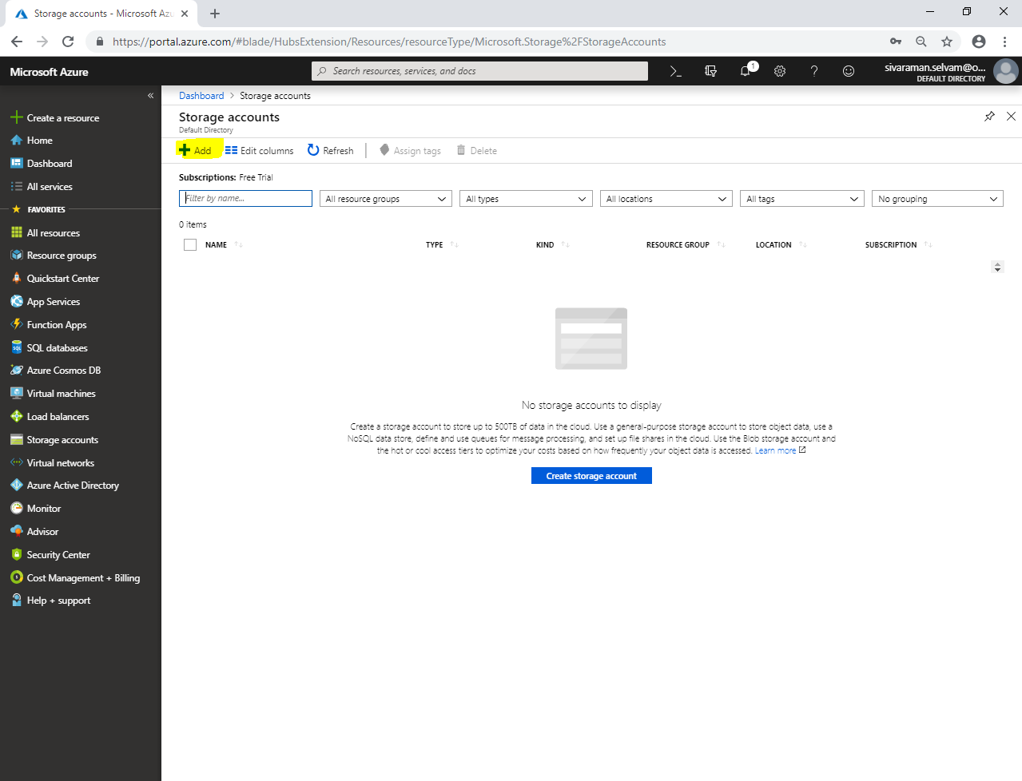

While create a storage account,

Select **“Subscription”** as **“Free Trial”**.

Select **“Resource group”** as **“SansboundAzureClass”**.

Type **“storage account name”** as **“sansboundstorage”**.

Select **“Location”** as **“Central US”**.

Select **“Performance”** as **“Standard”**.

Select **“Account kind”** as **“Blobstorage”**.

Select **“Replication”** as **“GRS”**.

Select **“Access tier”** as **“Hot”**.

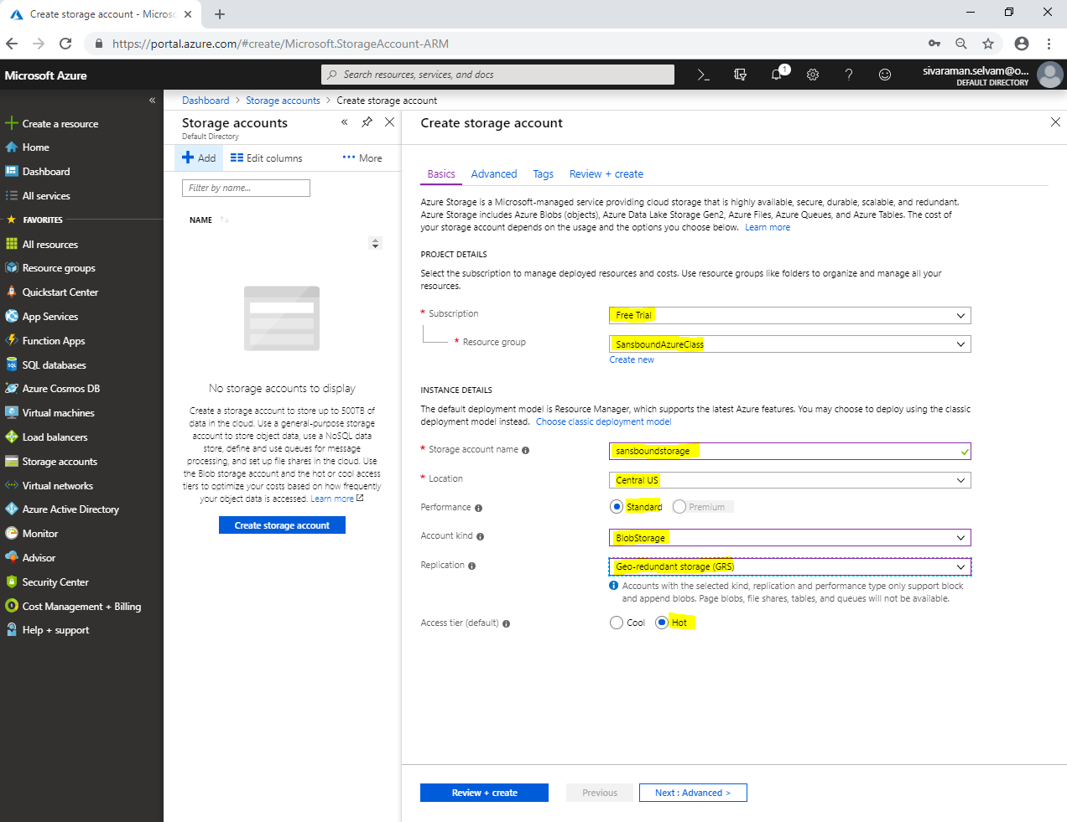

Click **“Review + create”**.

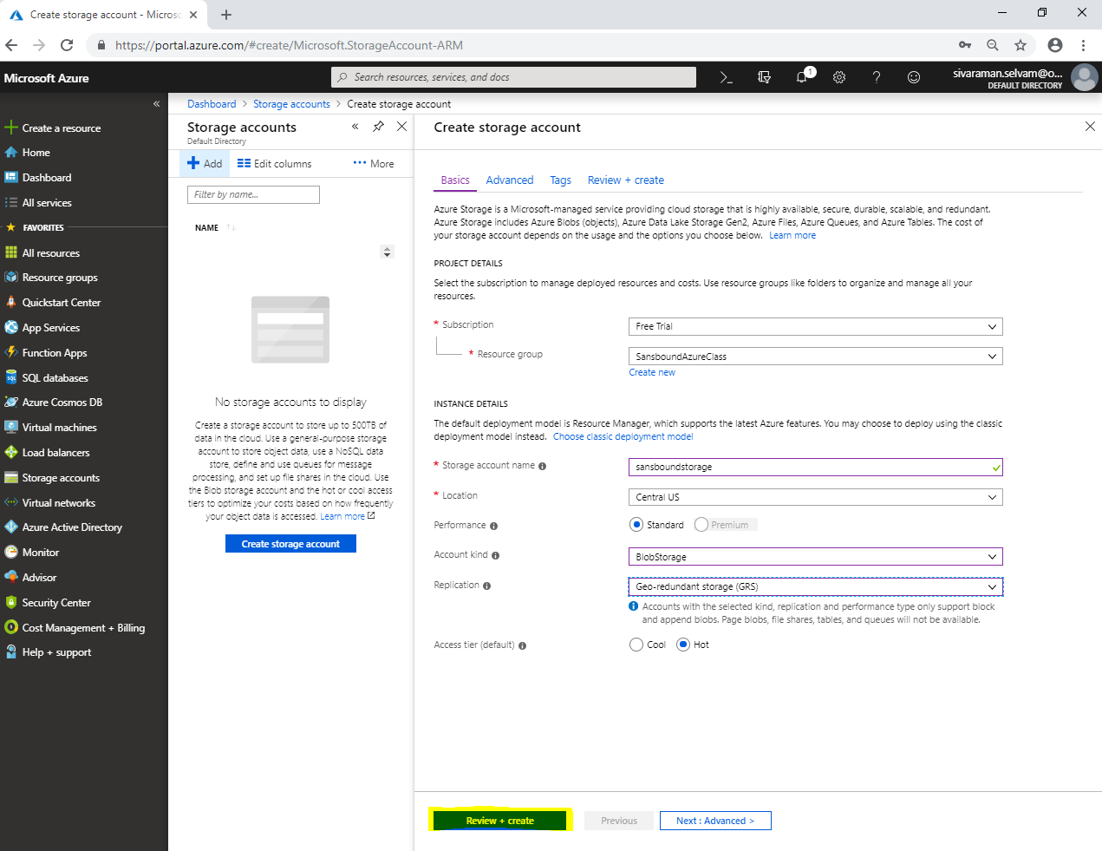

Click **“Create”**.

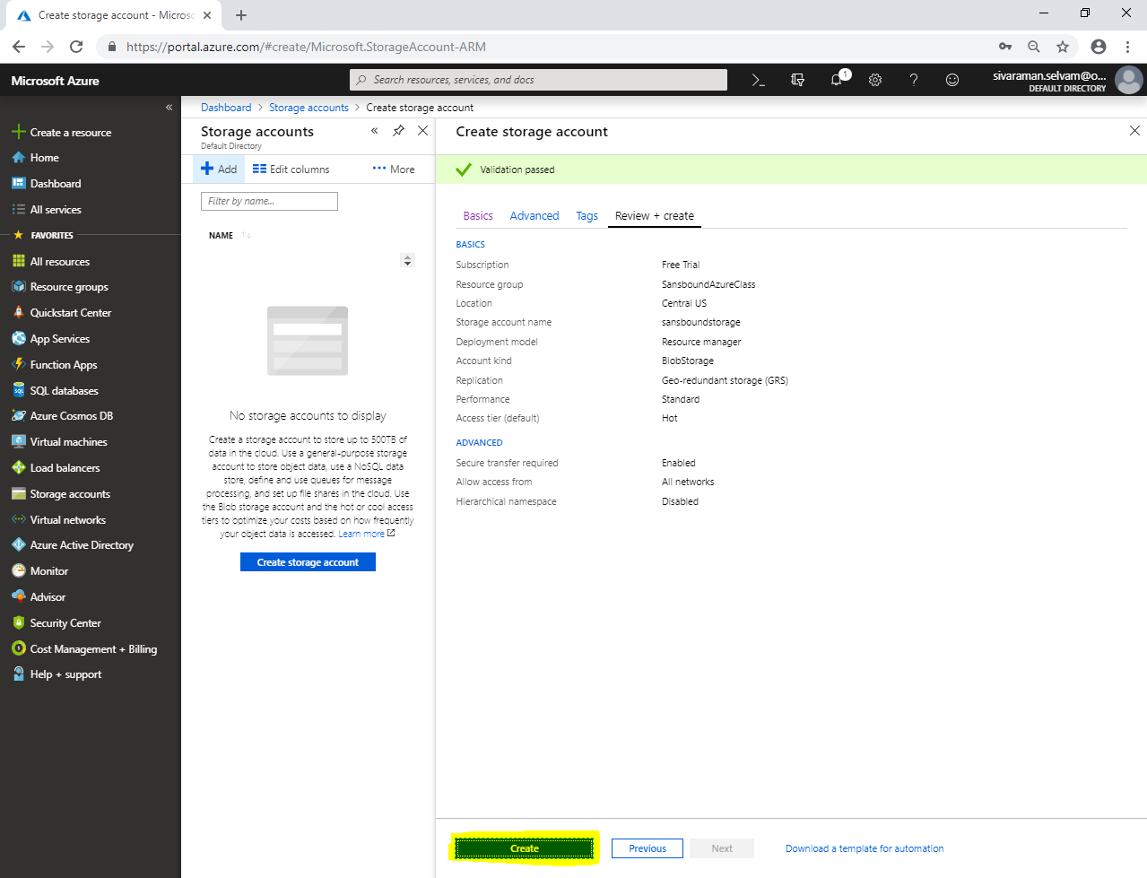

Click **“Go to resource”**.

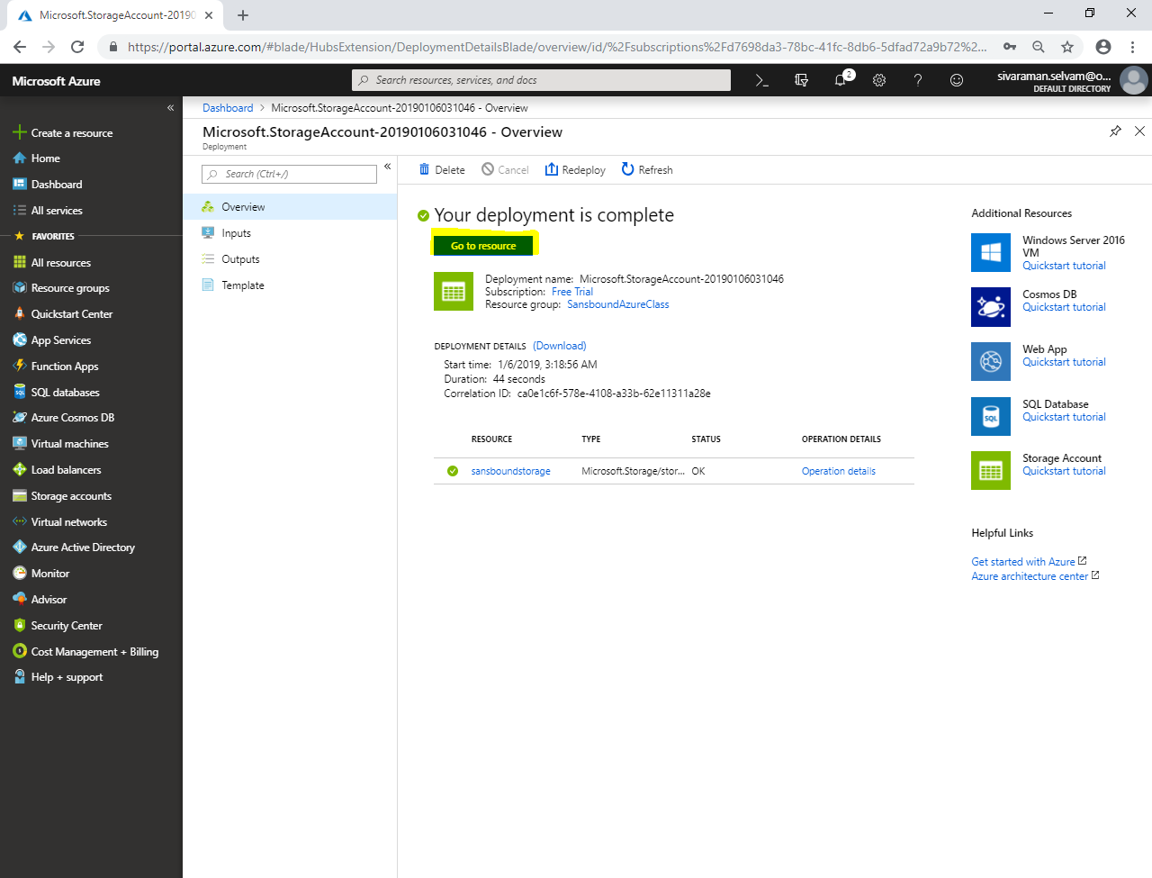

Click **“Blobs”**.

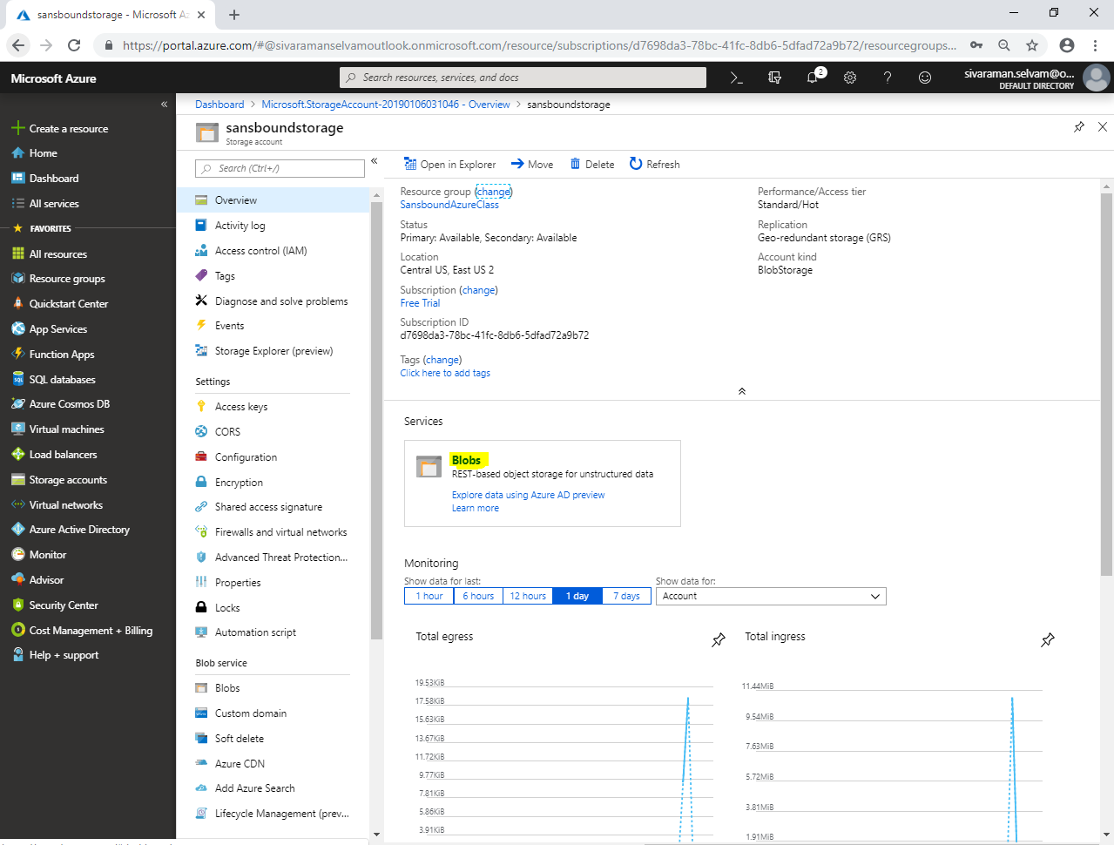

Click **“Container”** to create container.

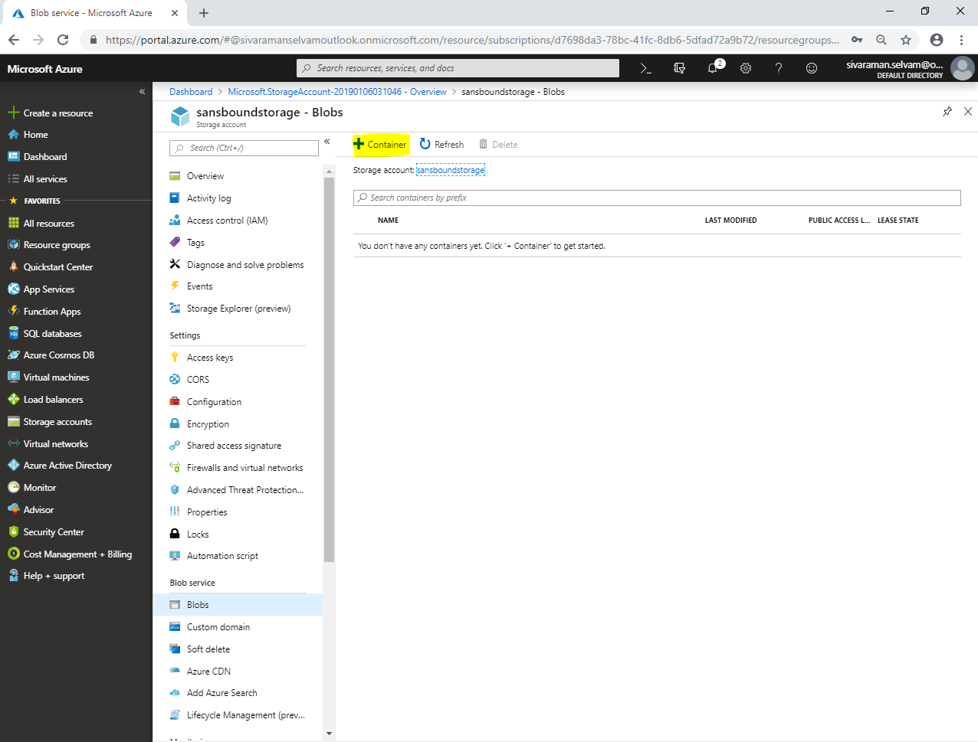

While create a container,

Type **“Name”** as **“aws”**.

Select **“Public access level”** as **“Container”**.

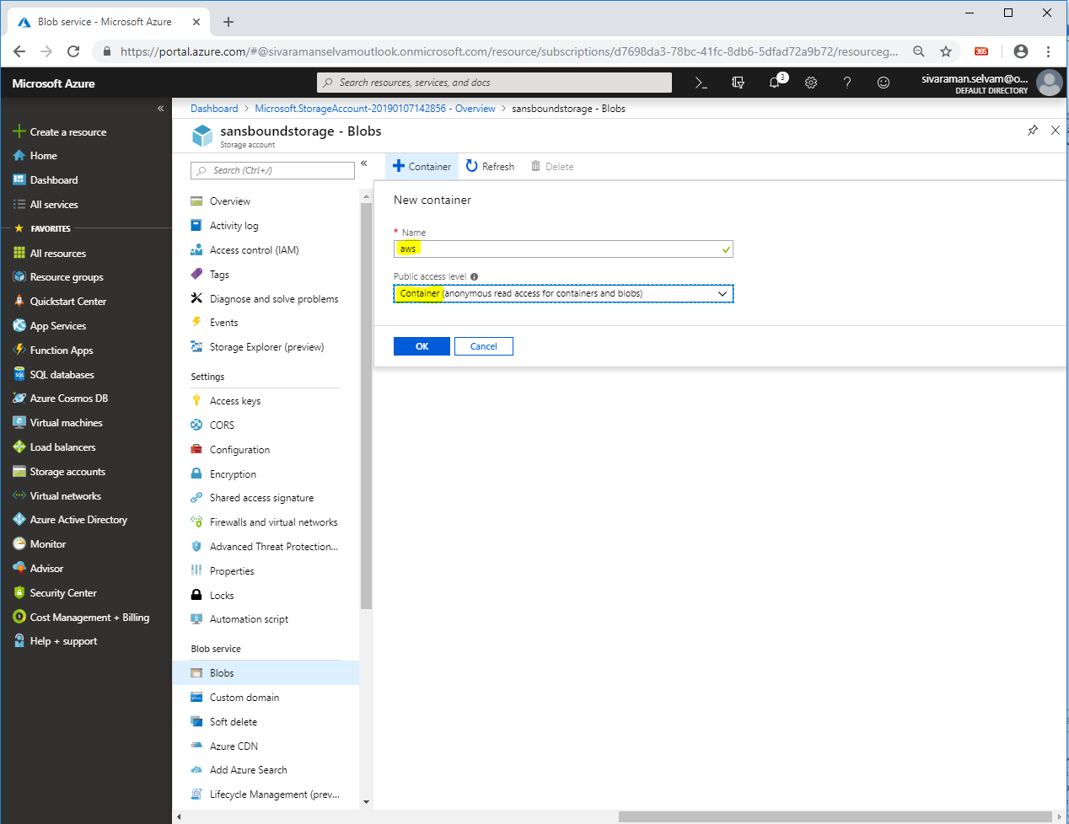

Click **“Ok”**.

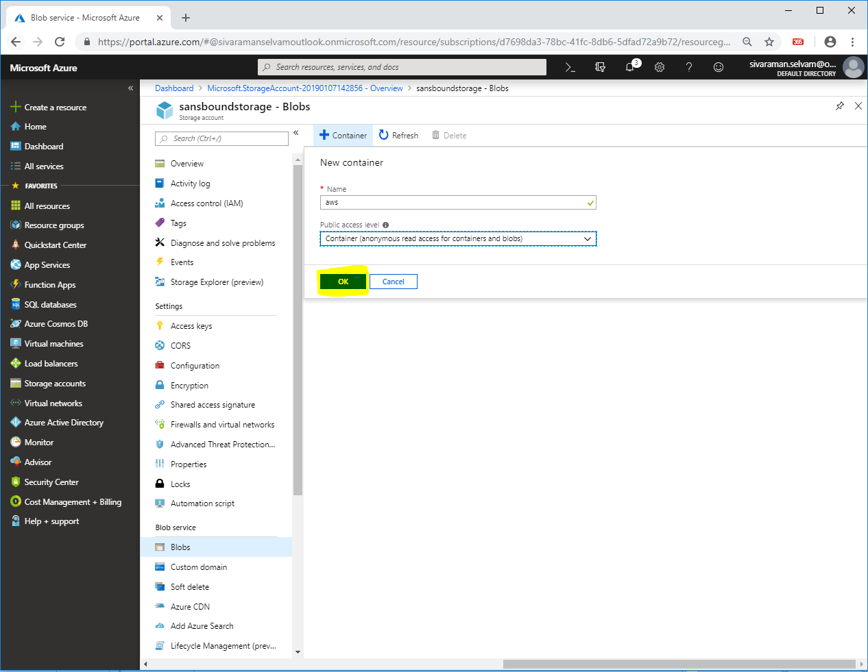

You are able to see that container named **“aws”** has been created successfully.

Click **“aws”**.

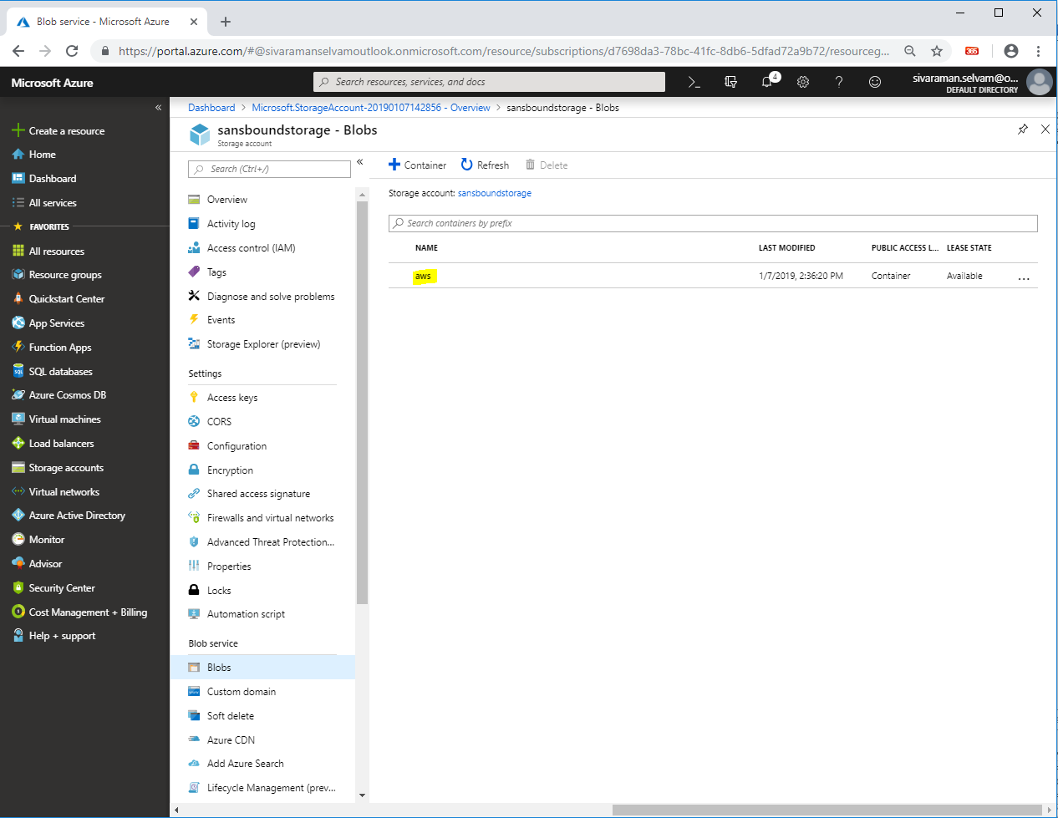

Click **“Upload”**.

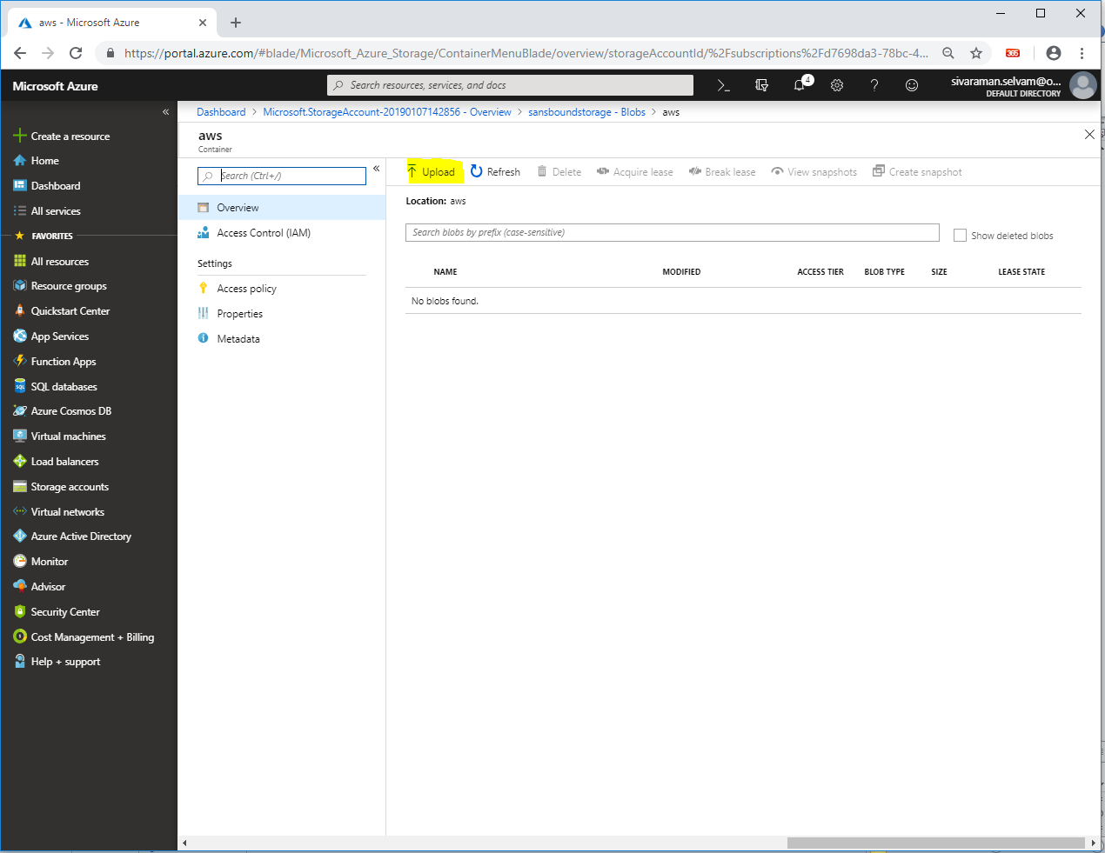

In **“Upload blob”,**

Click **“Icon”**.

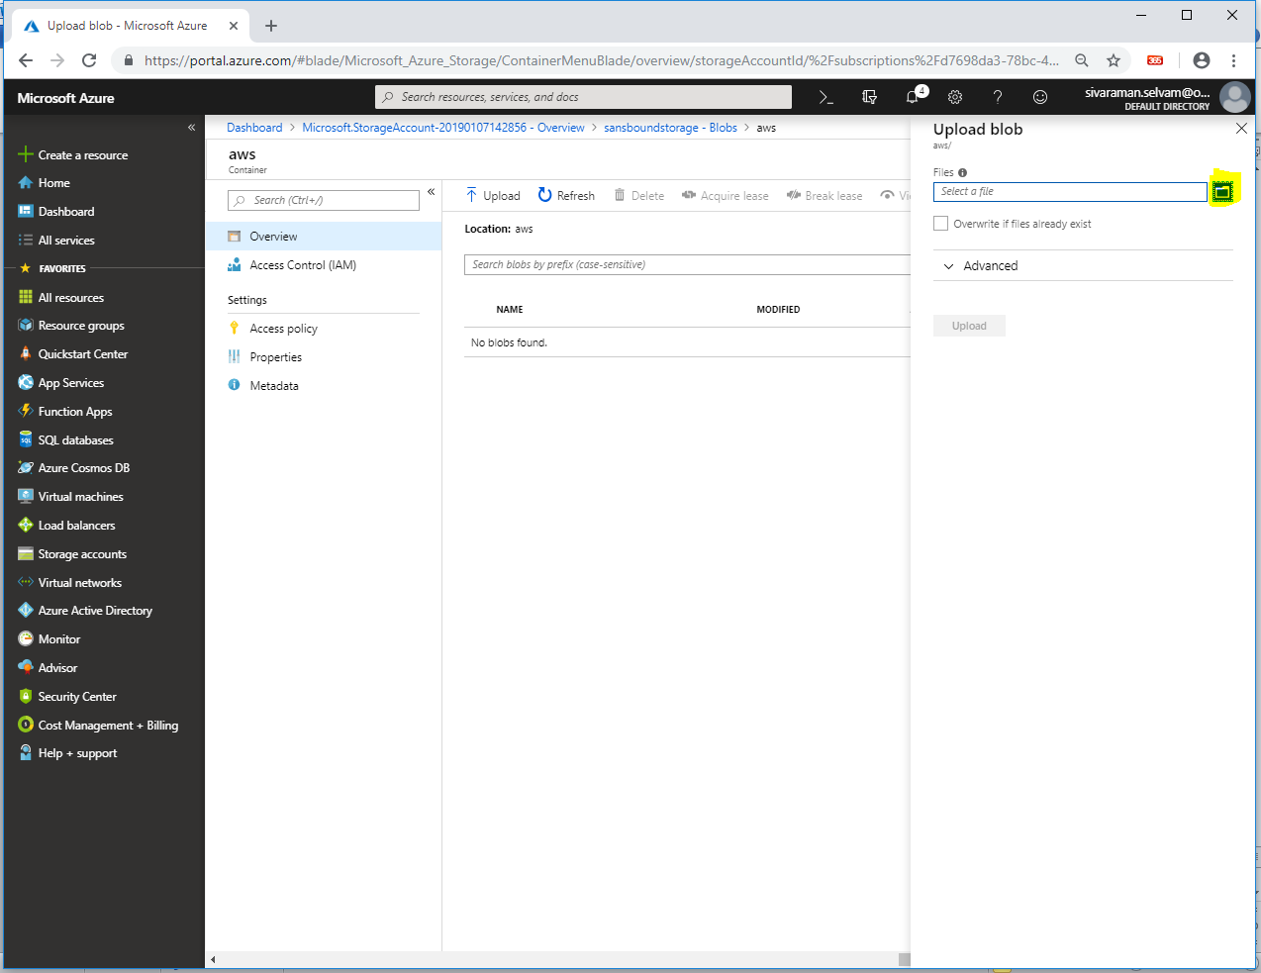

Browse and locate the file which you have required to upload.

Select the file and click **“Open”**.

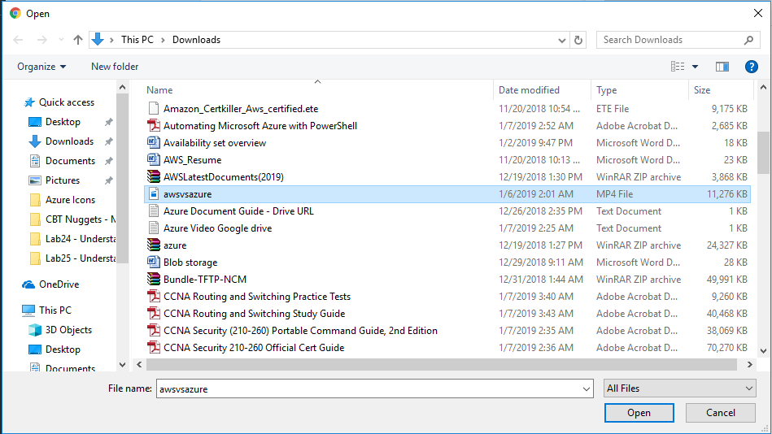

Click **“Upload”**.

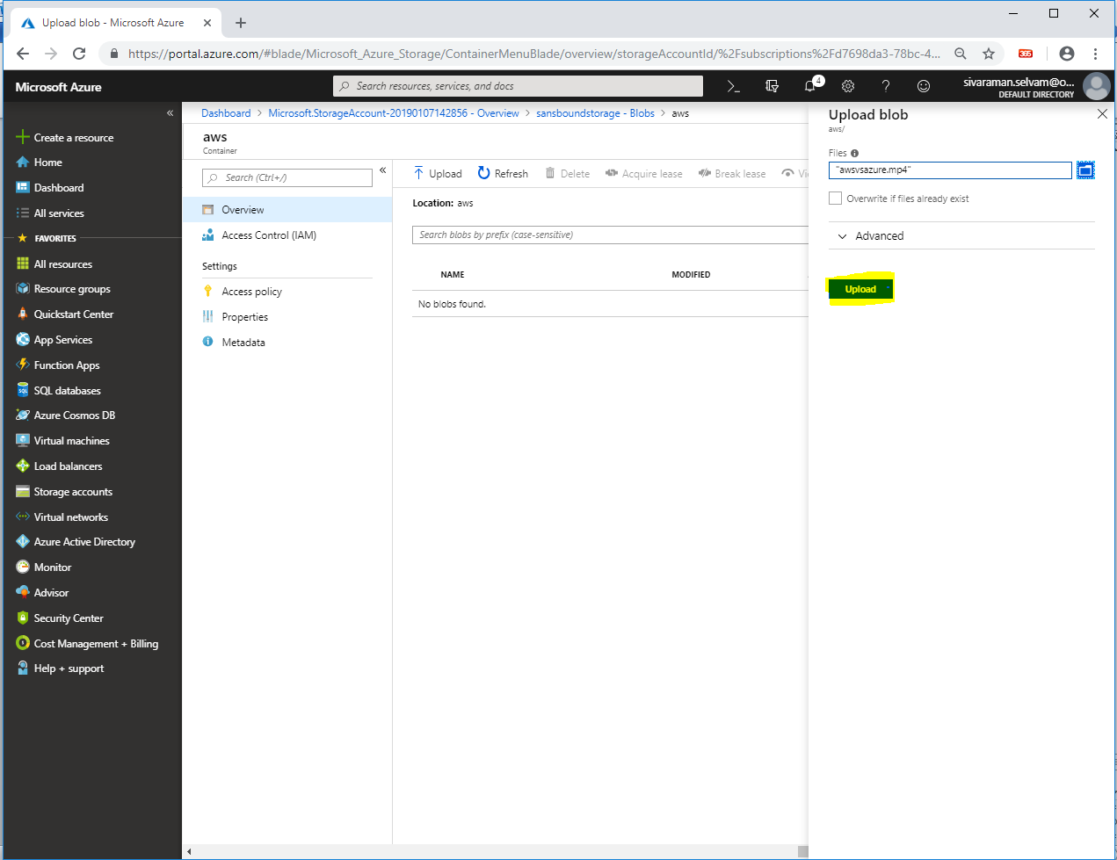

You have successfully uploaded the awsvsazure.mp4 file in blob successfully.

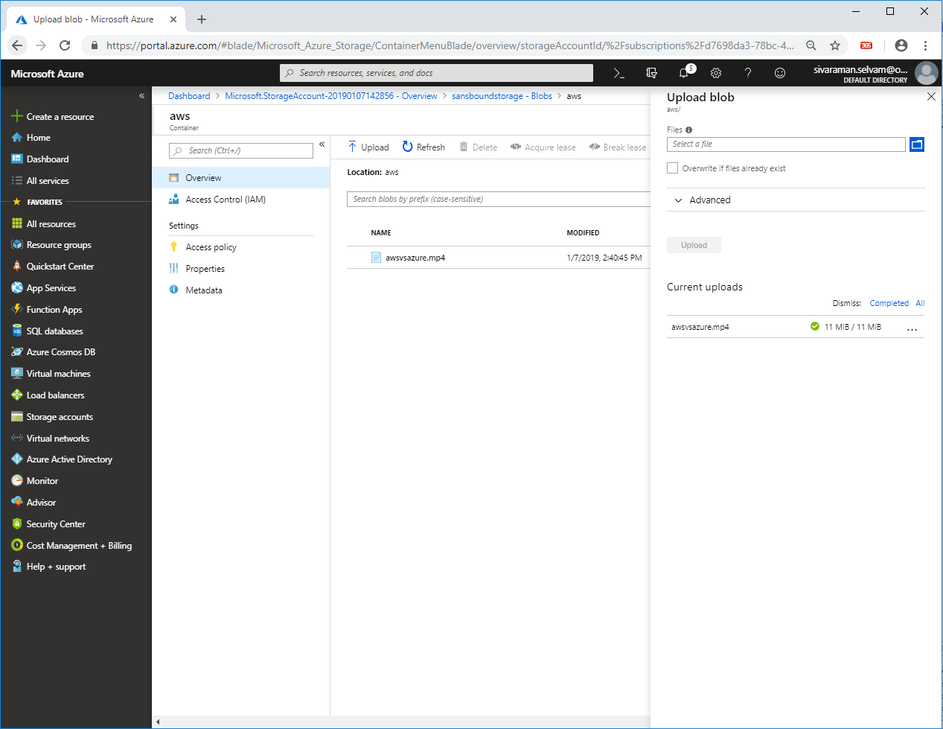

Click **“All services”**.

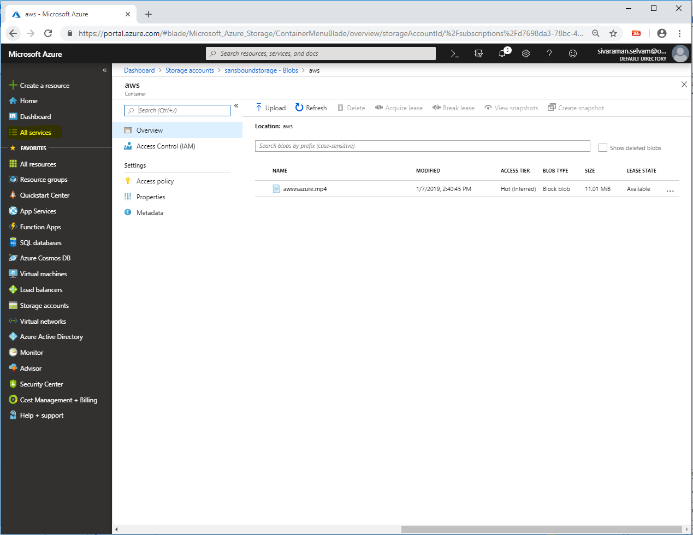

In **“All services”**,

Click **“CDN Profiles”**.

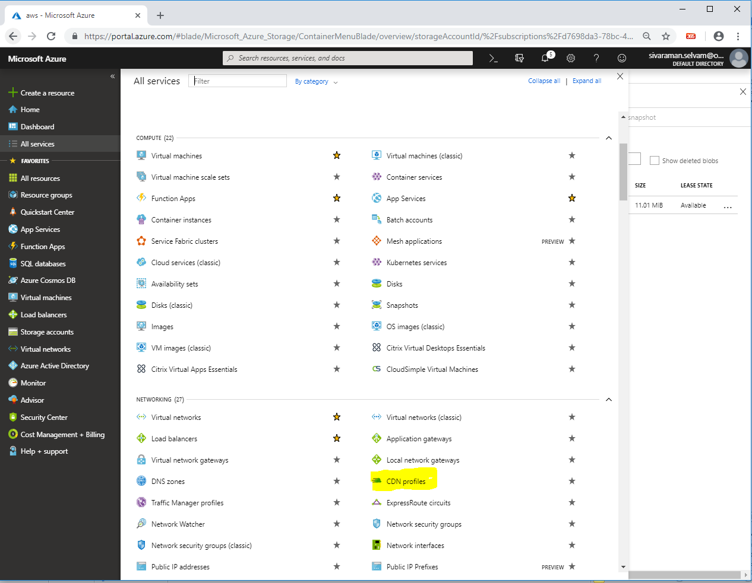

Click **“Add”**.

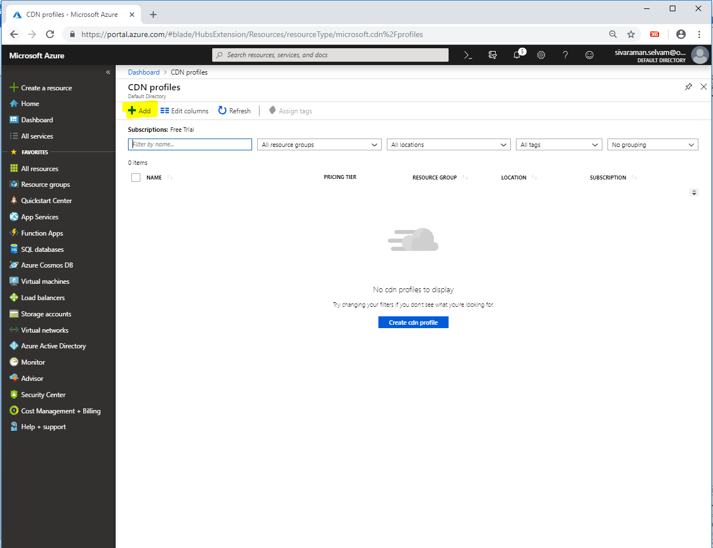

In **“CDN Profile”**,

Type **“Name”** as **“sansmediacdn”**.

Select **“Subscription”** as **“Free Trial”**.

Select **“Resource group”** as **“SansboundAzureClass”**.

Select **“Pricing tier”** as **“Standard Microsoft”**.

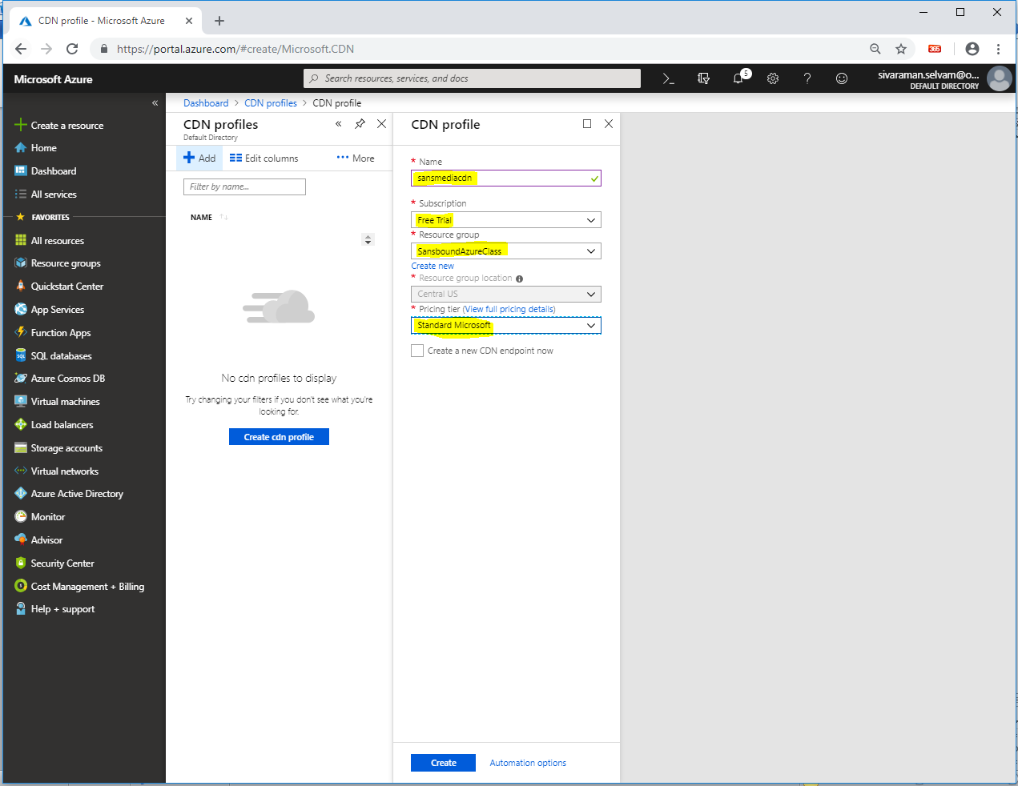

Click **”Create”**.

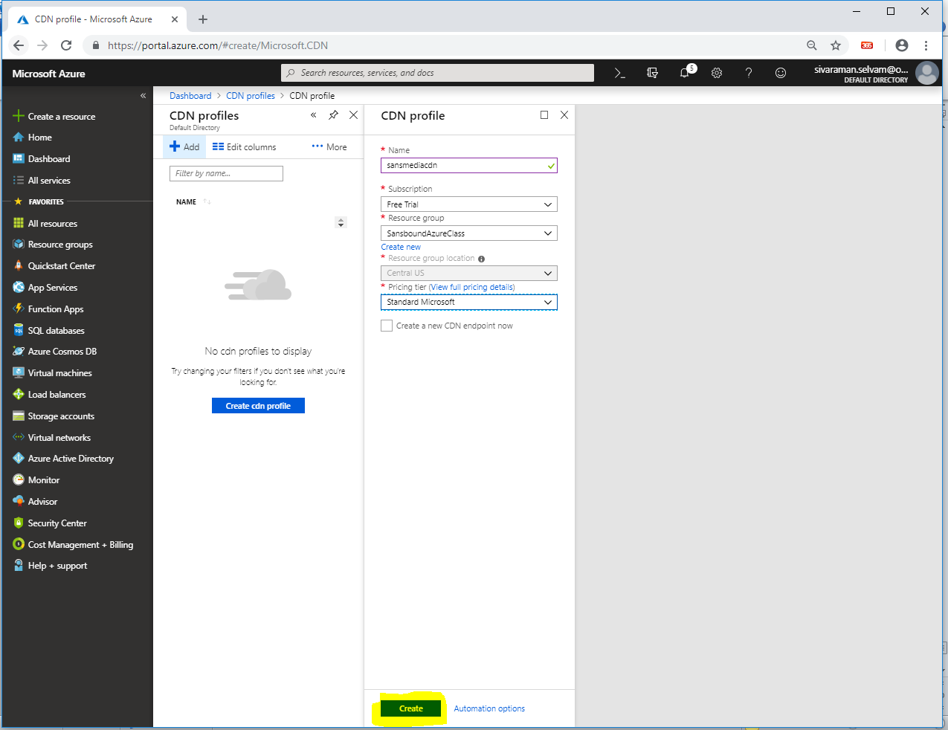

In **“CDN profiles”**,

Click **“sansmediacdn”**.

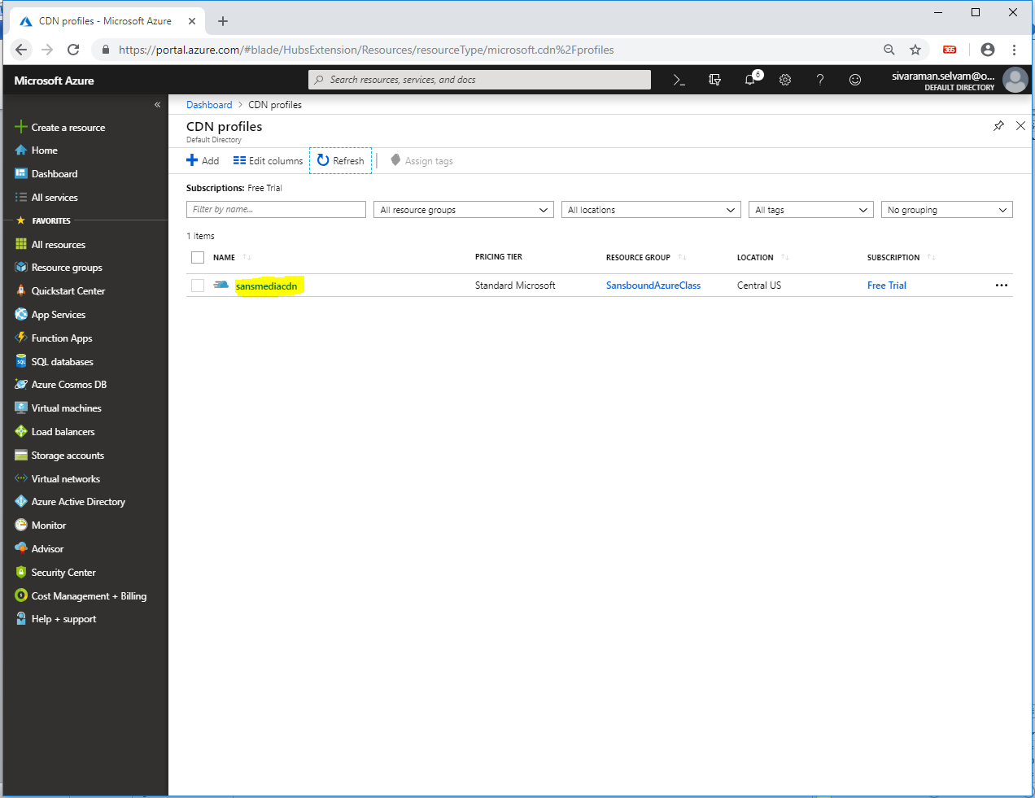

Click **“Endpoint”**.

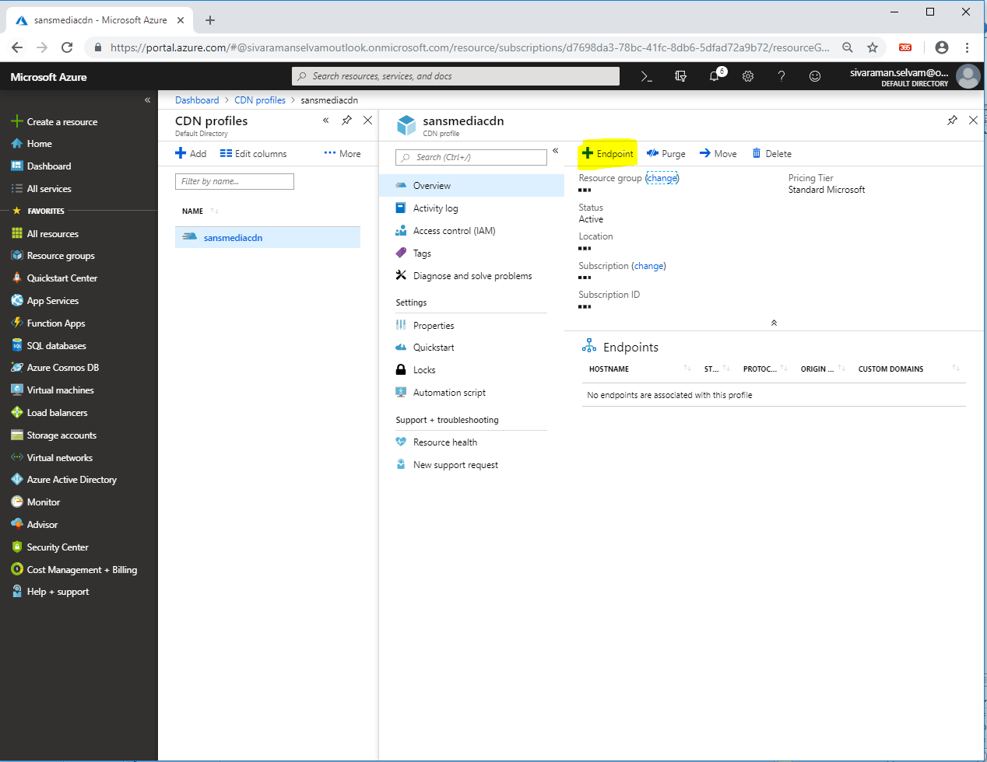

While **“Add an endpoint”**,

Type **“Name”** as **“aws”**.

Select **“Origin”** as **“Storage”**.

Select **“Origin hostname”** as **“sansboundstorage.blob.core.windows.net”** (Name of the storage account).

Select **“Origin path”** as **“/aws”** (aws is a container name).

Ensure **“http”** and **“https”** are selected.

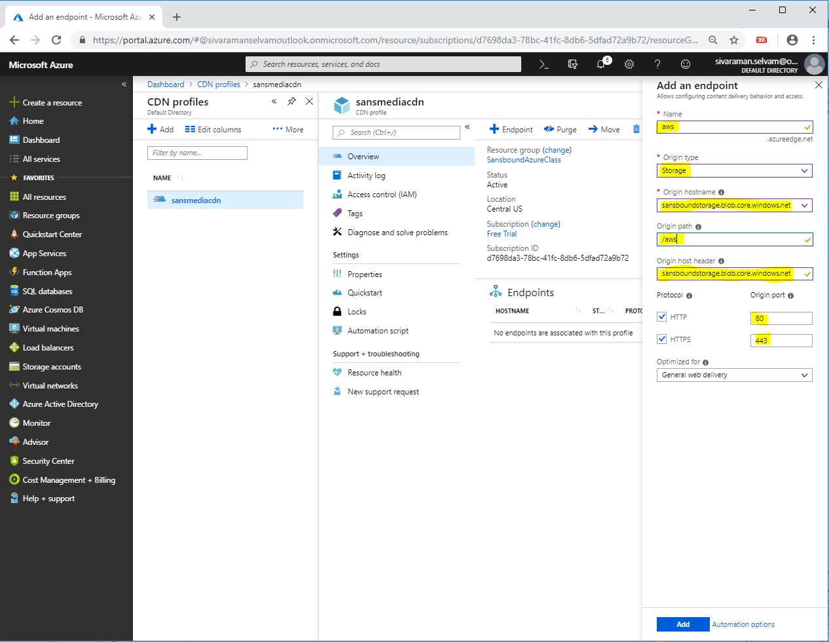

Click **“Add”**.

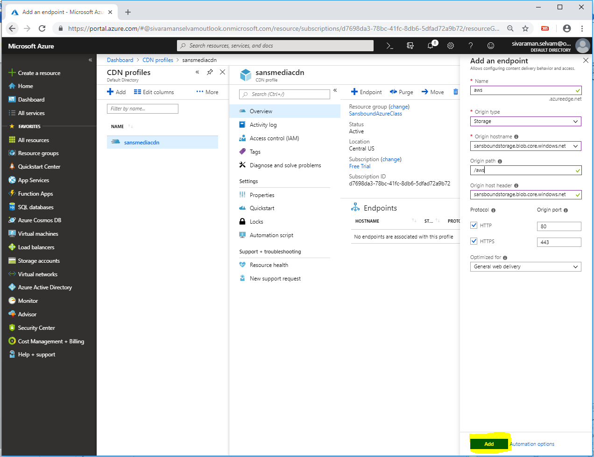

You are able to see the endpoint for **“sansmediacdn”.**

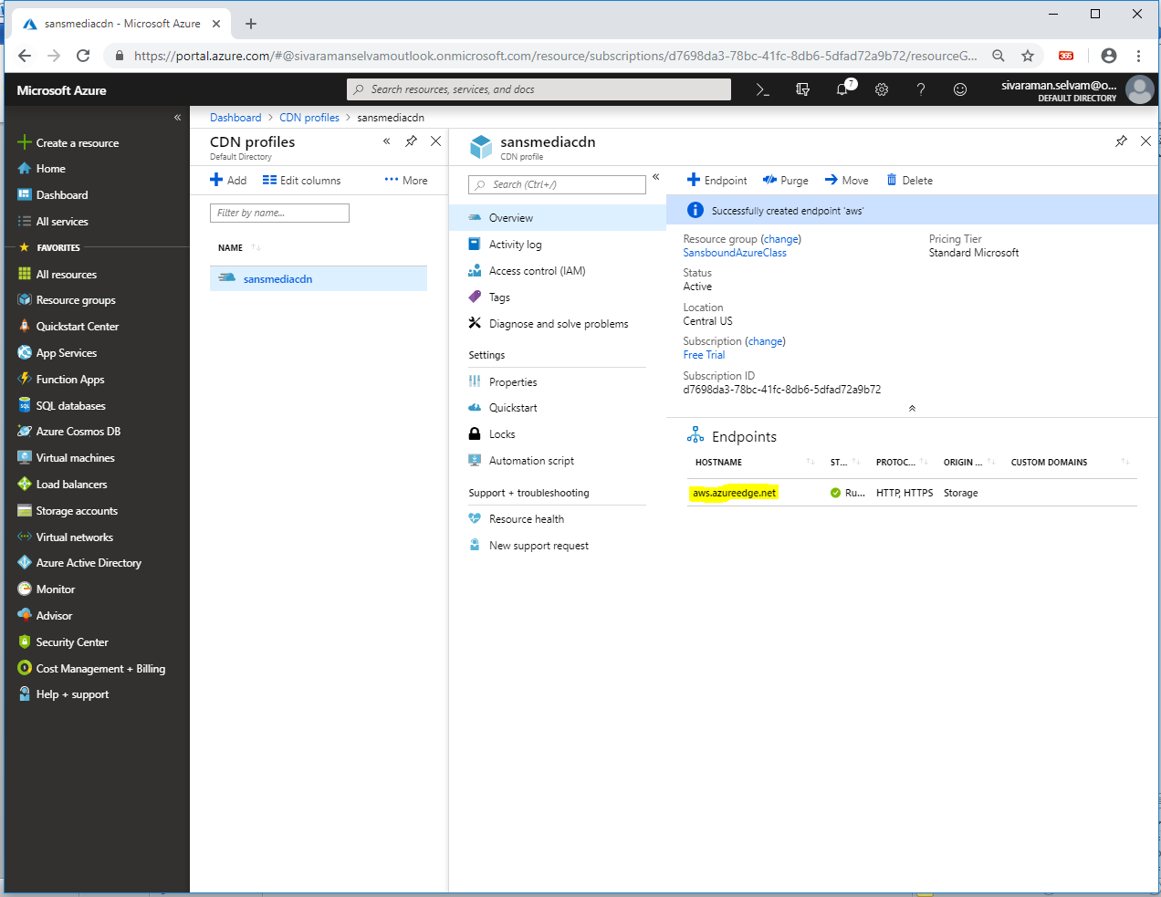

Click **“Storage accounts”** in left side panel.

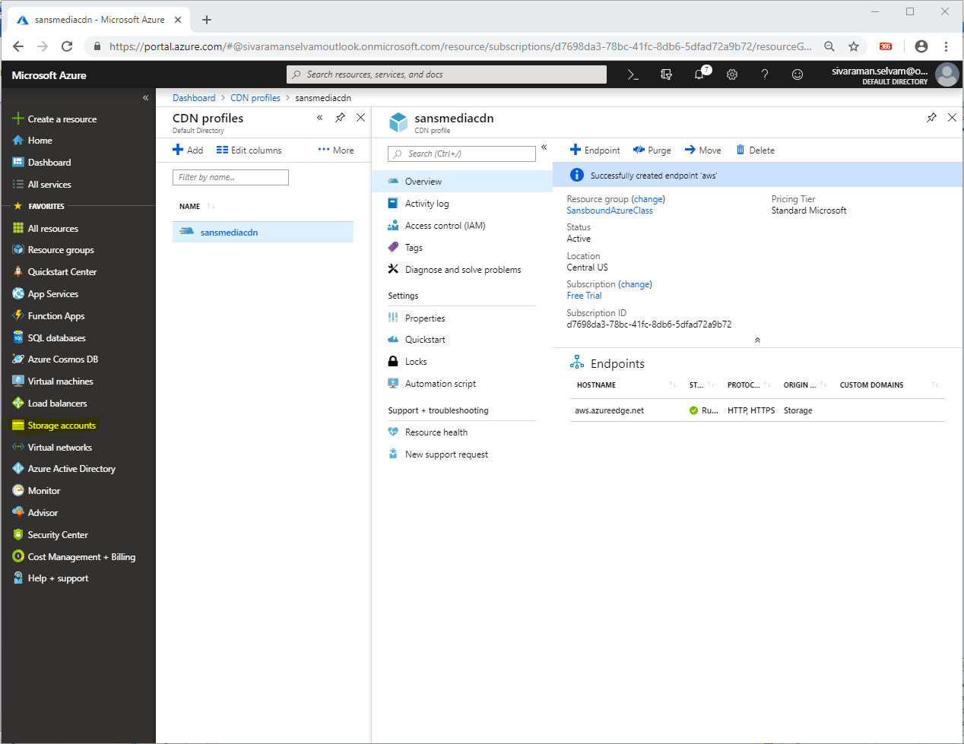

In **“Storage accounts”**,

Click **“sansboundstorage”**.

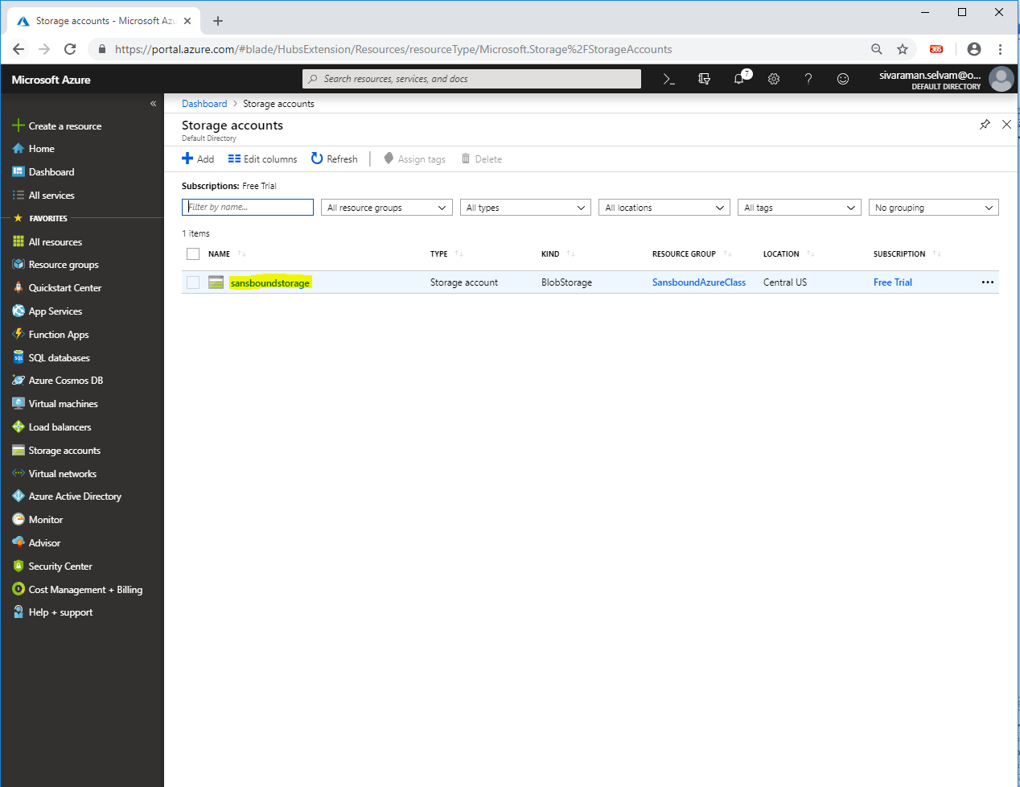

Click **“Blobs”**.

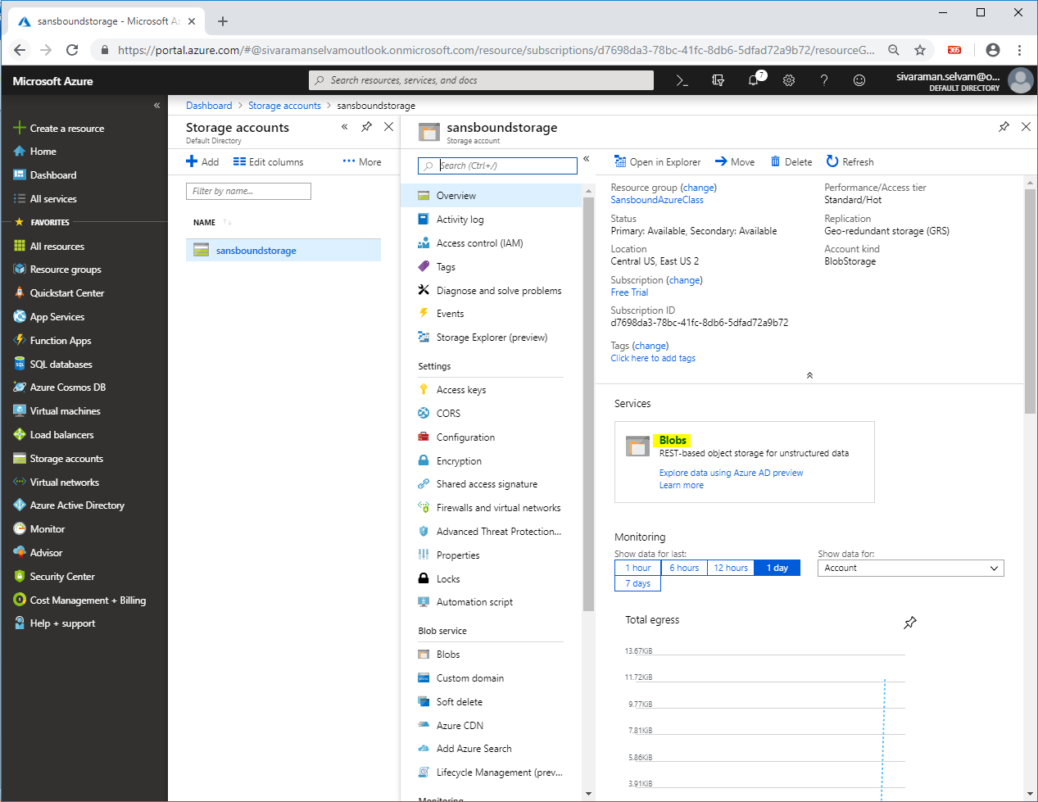

Click **“aws”** container.

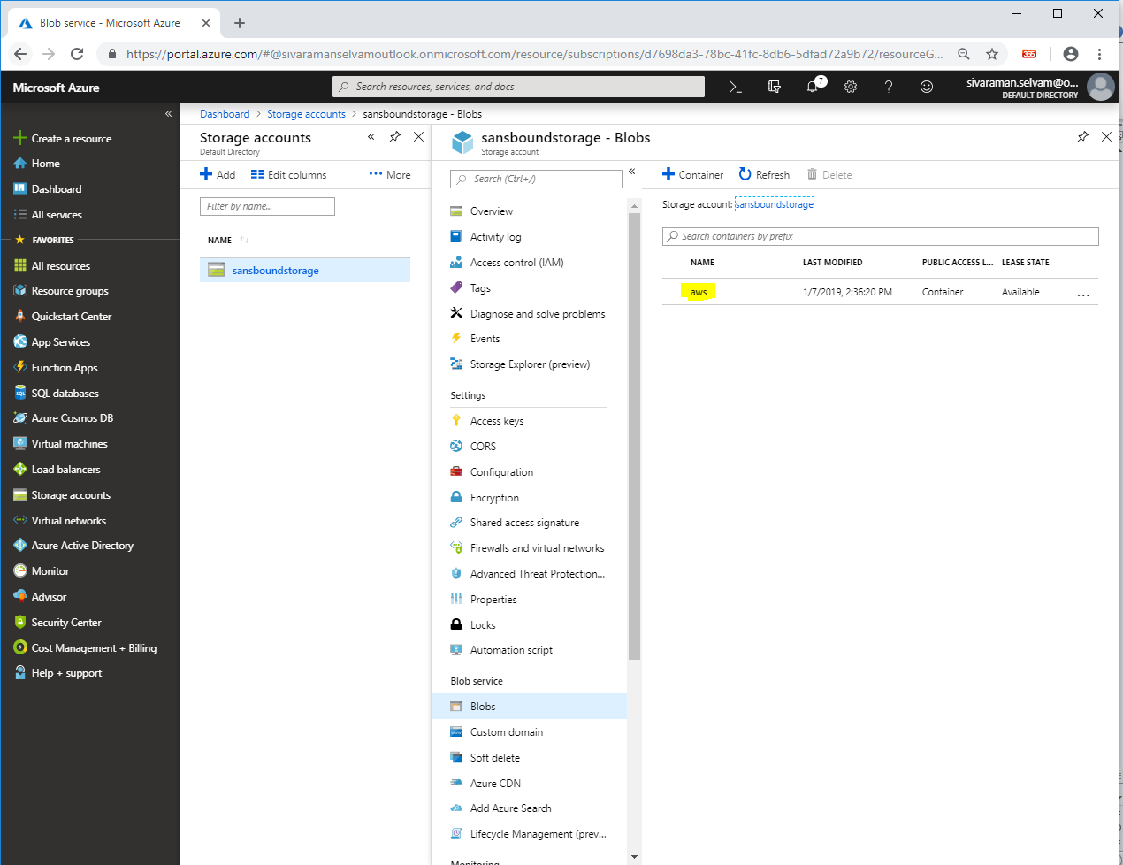

Click **“Generate SAS”**.

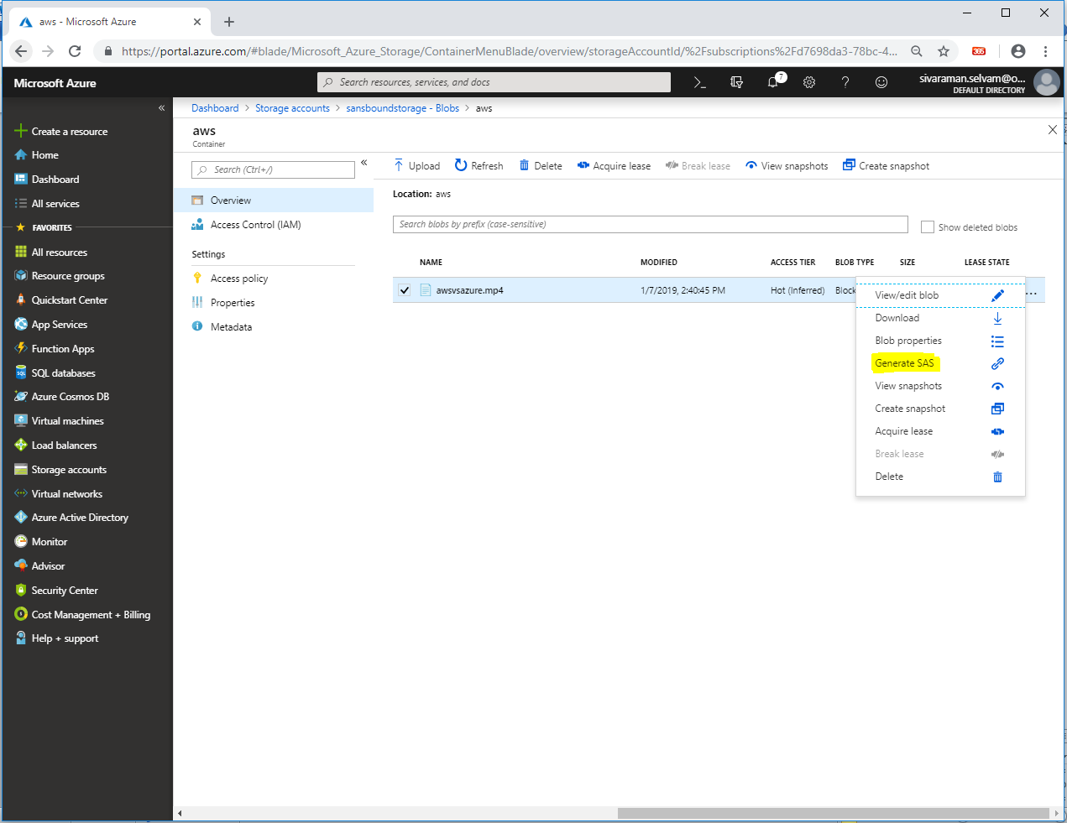

Click **“Generate blob SAS token and URL”**.

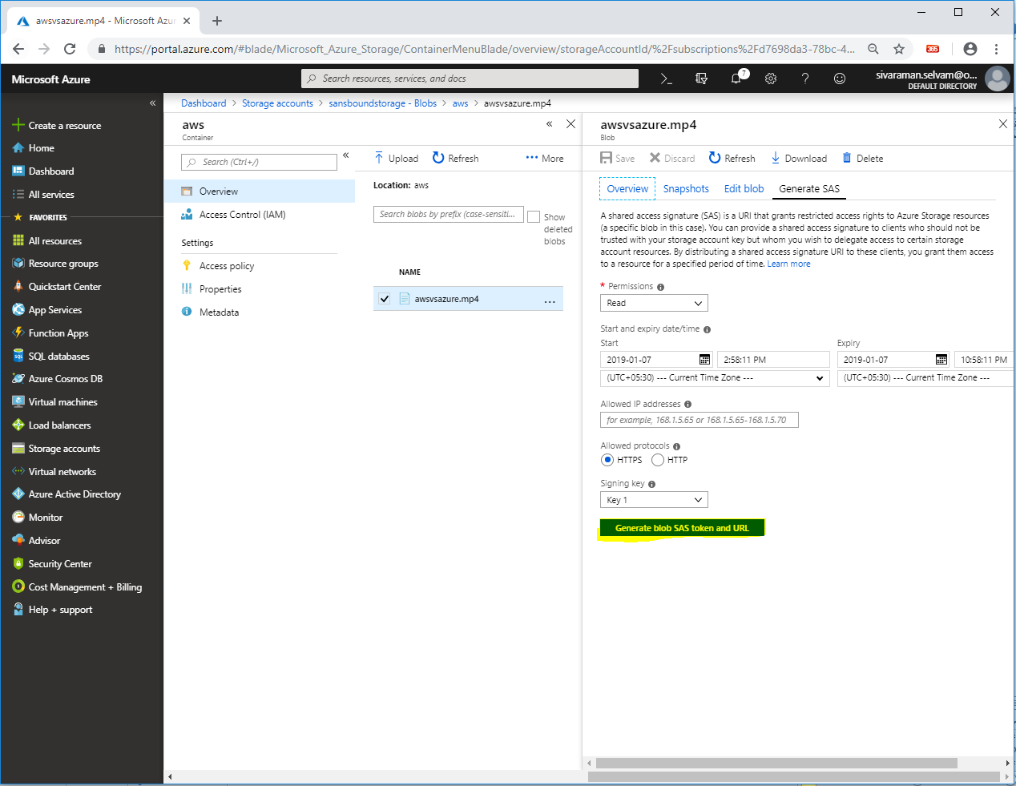

Click **“Icon”** to copy the Blob SAS URL Path.

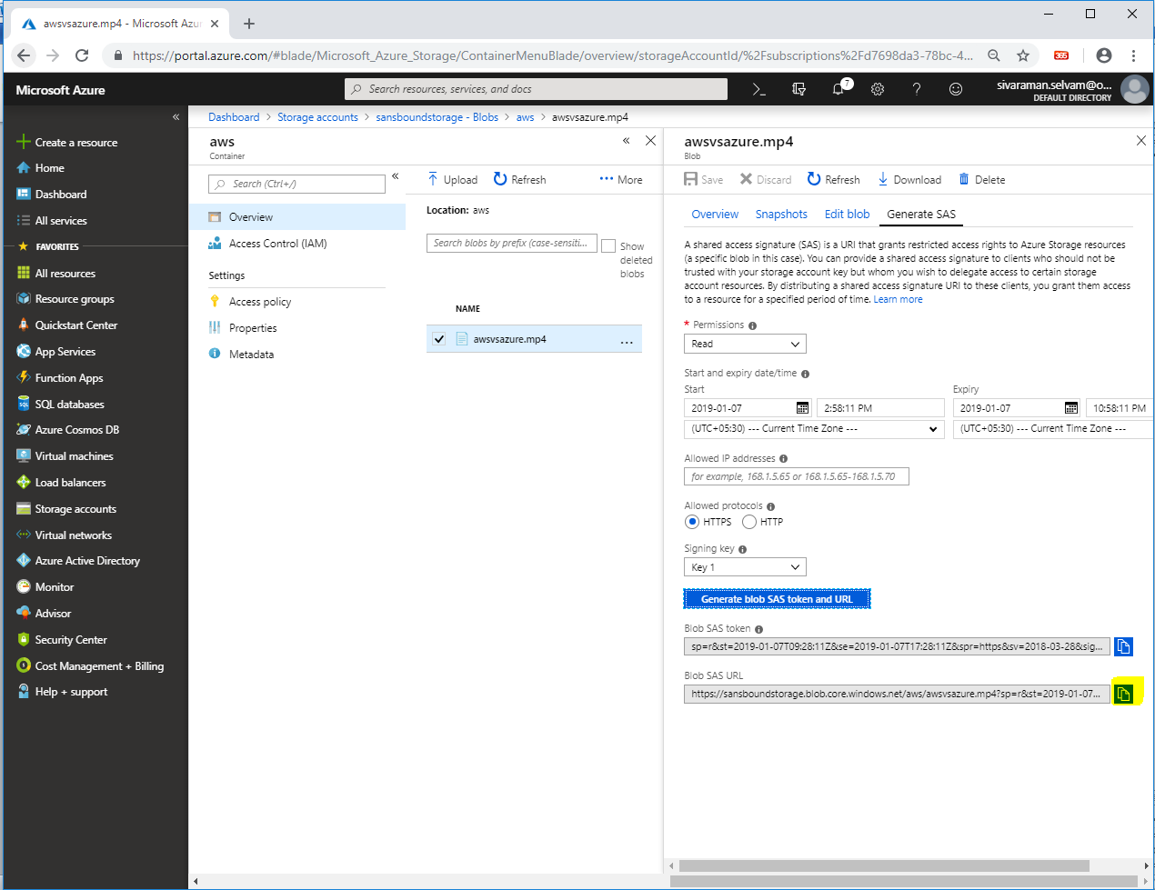

Click **“All resources”**.

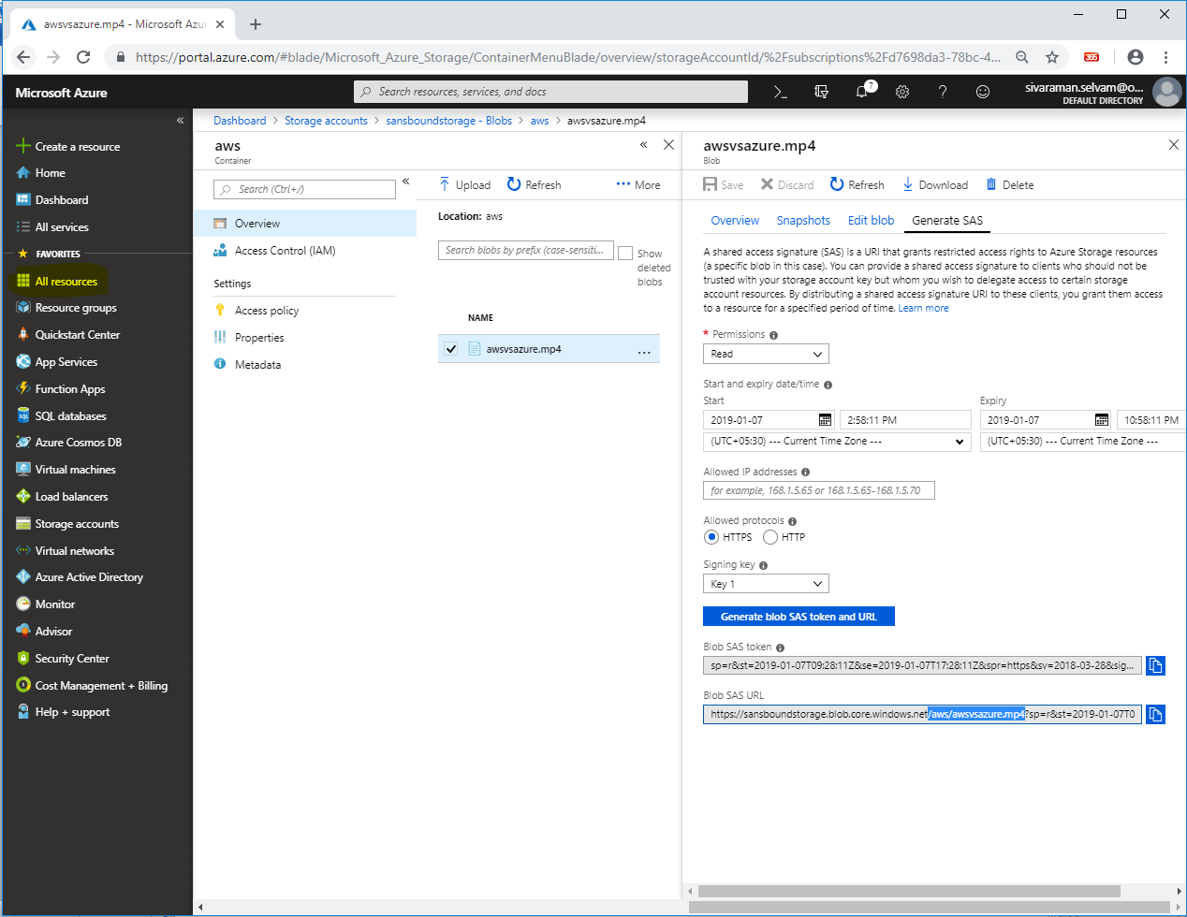

Click **“sansmedia/aws”** endpoint of CDN.

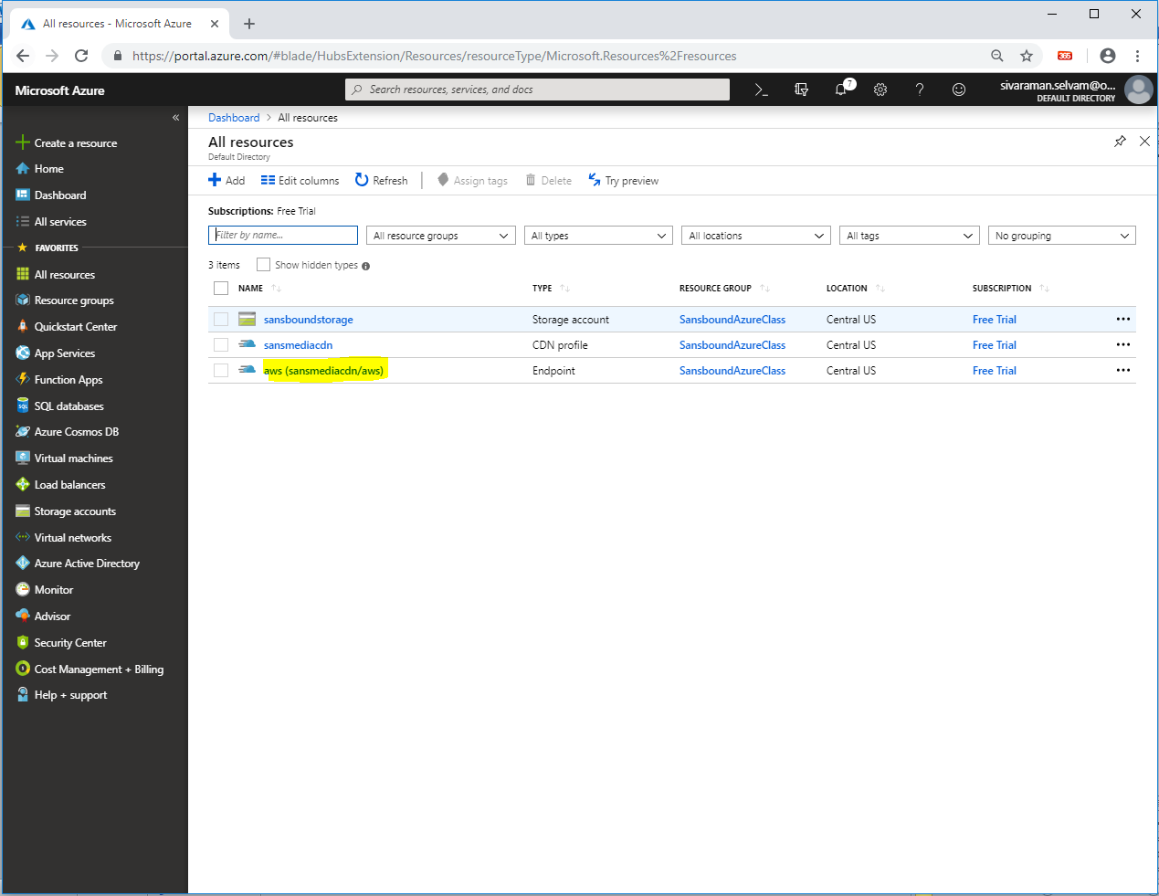

Copy the path **“https://aws.azureedge.net”**

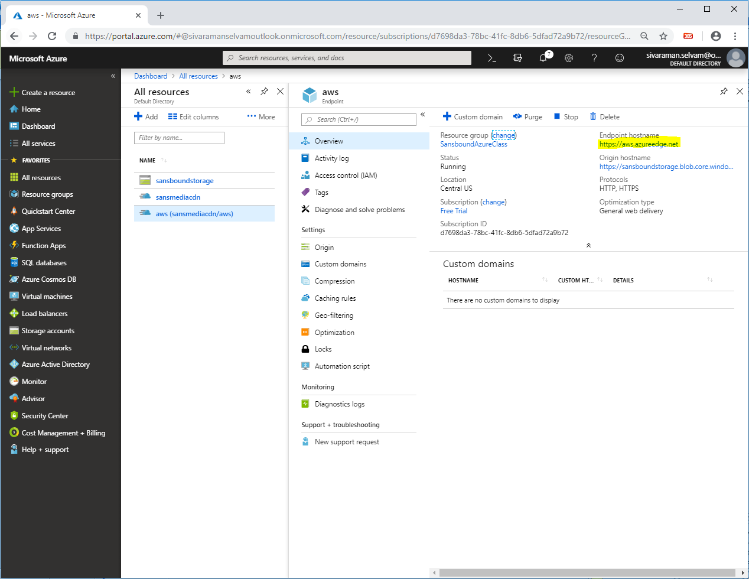

Paste the path into browser with “filename”.

[https://aws.azureedge.net/**awsvsazure.mp4**](https://aws.azureedge.net/awsvsazure.mp4)

**and press “Enter”.**

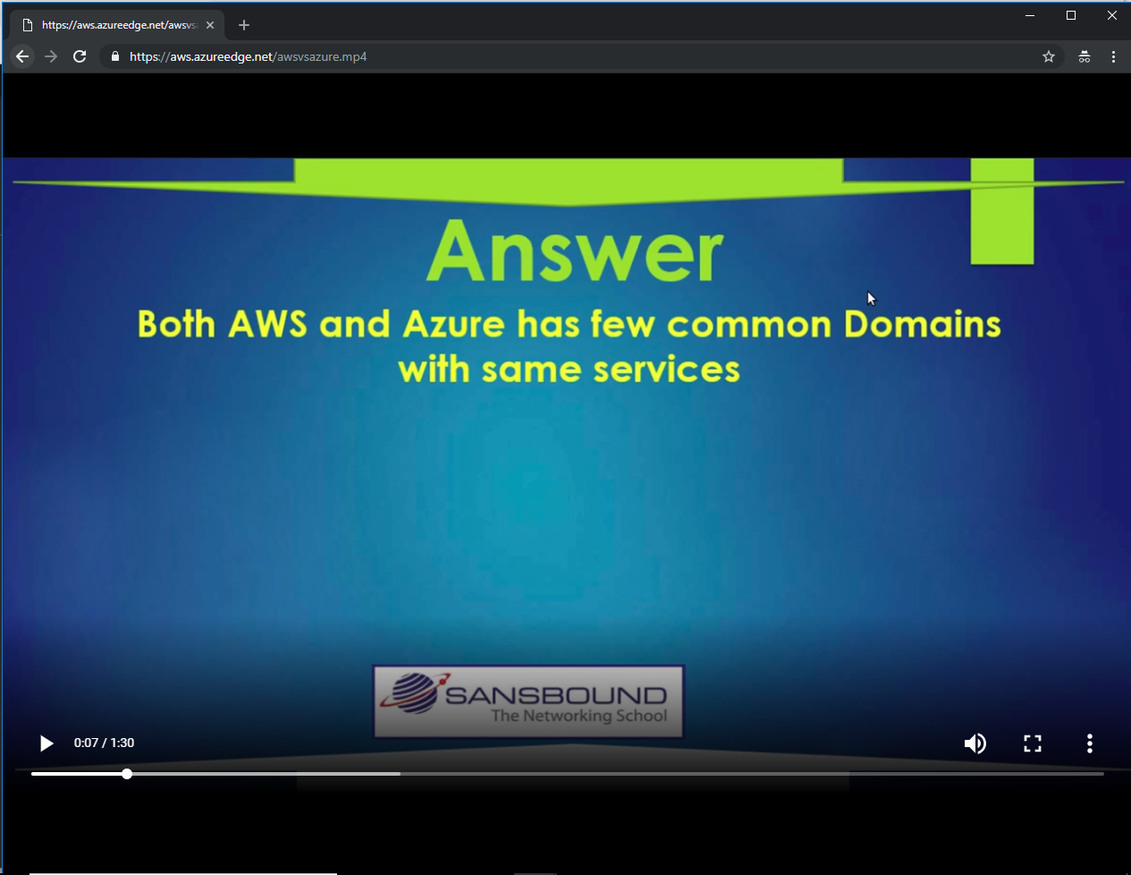

I have got the video file through Endpoint of CDN profile.